**SE - OOP Concept**

{C++ Language}

‘Object – Oriented Programming’

**MODULES:-[4.1, 4.2, 4.3]**

**Submitted to:-**

**Ms. Heena Malek**

**Submitted to:-**

**Ankita Sahu**

MODULE: 4.1 (C++ Basic)

**1. WAP to print “Hello World” using C++.**

**Ans:-**

Practical:-

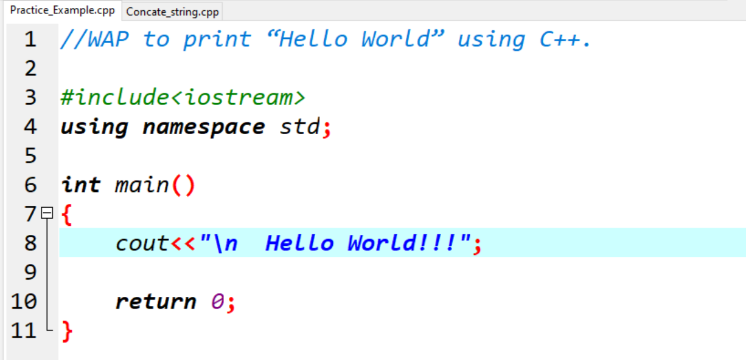

Output:-

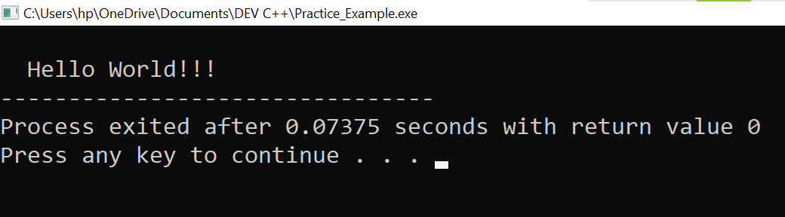

**2. What is OOP? List OOP concepts .**

**Ans:-**

**OOP_ (Object Oriented Programming).**

* **Emphasis on data rather than Procedure .**
* **Program are divided into Objects .**
* **Data is hidden and cannot be accessed by external functions.**
* **Objects may communicate with each other through functions.**
* **Follows bottom up approach in program design.**

**List Out OOP Concepts –:**

1. Class

2. Object

3. Encapsulation

4. Polymorphism

5. Inheritance

6. Data Abstraction

7. Message Passing & Dynamic Binding

**3. What is the difference between OOP and POP?**

**Ans:-**

|  |  |
| --- | --- |
| **POP** | **OOP** |
| 1. POP_ Procedure Oriented programming. | 1. OOP_ Object Oriented Programming. |
| 2. Emphasis is on doing things. | 2. Emphasis on data rather than Procedure. |
| 3. Larger Programs are broken into small known as functions. | 3. Program are divided into Objects. |
| 4. Most of the function share global data. | 4. Data is hidden and cannot be accessed by external functions. |
| 5. Data move openly around the system from functions to functions. | 5. Objects may communicate with each other through functions. |
| 6. Follows Top-Down approach in program design. | 6. Follows bottom up approach in program design. |
| 7. Ex:- C, Pascal , V.B, etc.. | 7. Ex:- C++, Java, Python, etc.. |

MODULE : 4.2 (Programing with C++)

**1. WAP to create simple calculator using class.**

**Ans:-**

Practical:

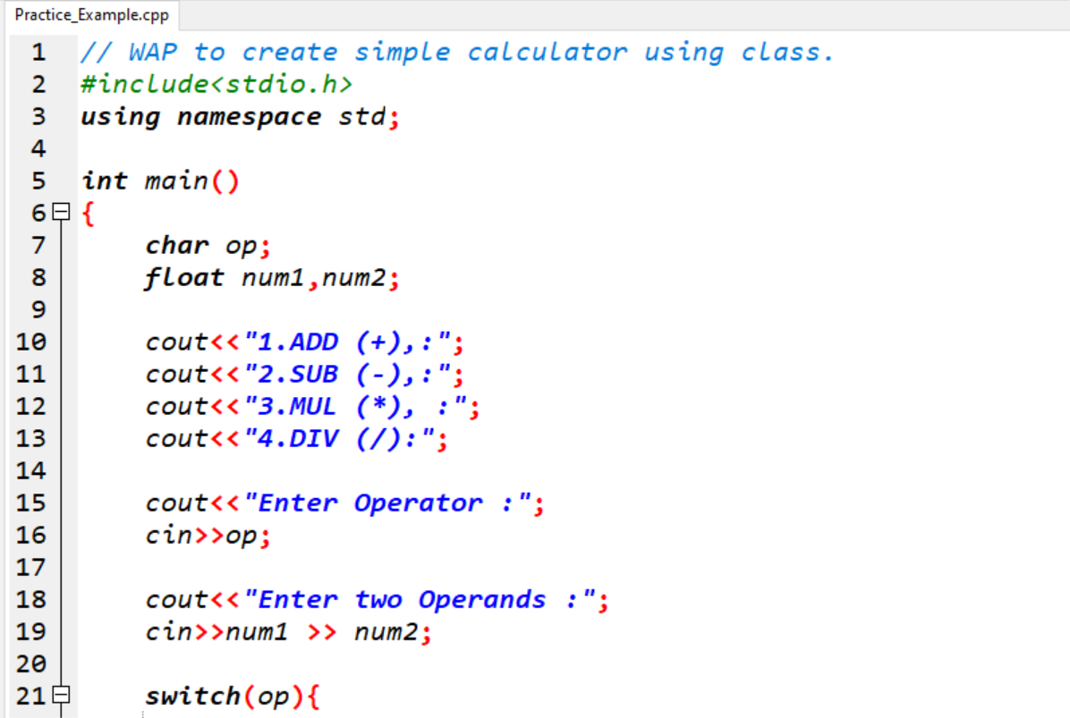

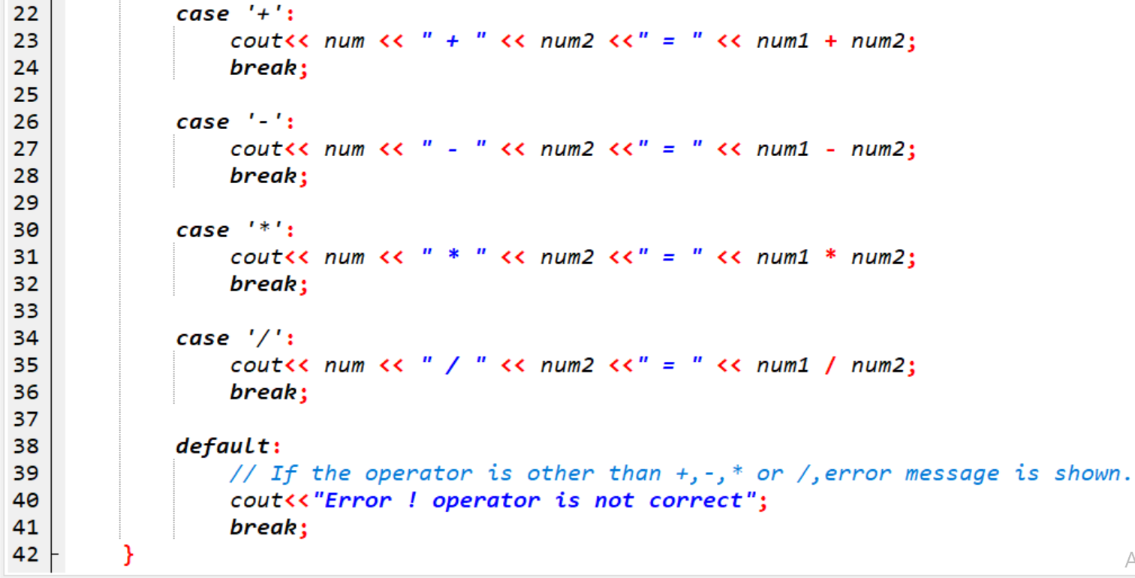

Output:

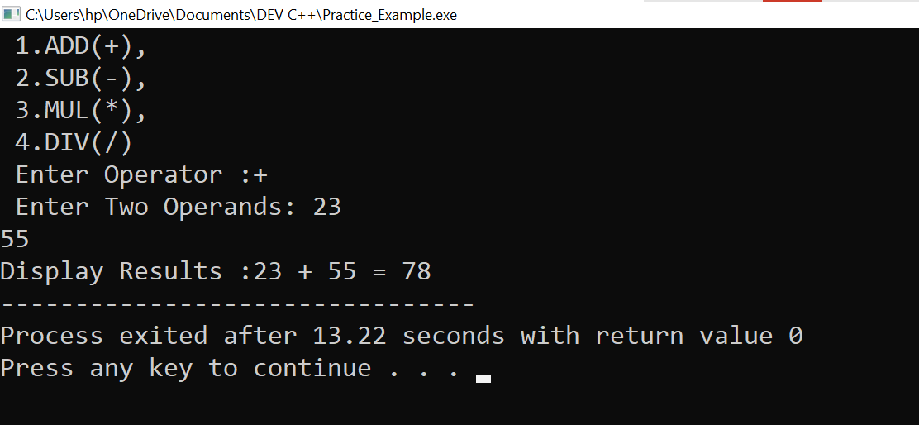

**2. Define a class to represent a bank account. Include the following members:**

**i. Data Member: -**

**-Name of the depositor**

**-Account Number**

**-Type of Account**

**-Balance amount in the account**

**ii. Member Functions**

**-To assign values**

**-To deposited an amount**

**-To withdraw an amount after checking balance**

**-To display name and balance**

**Ans:-**

Practical:

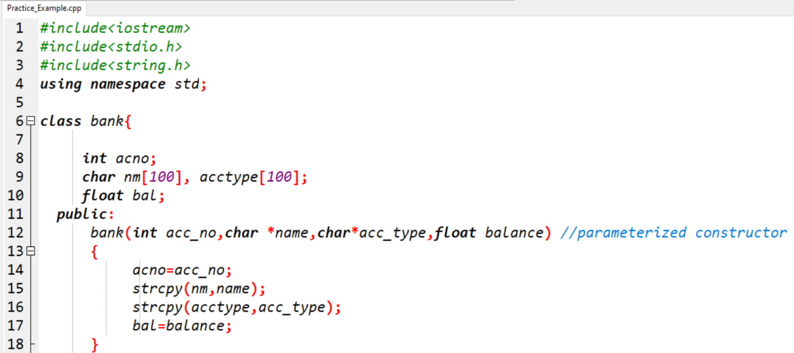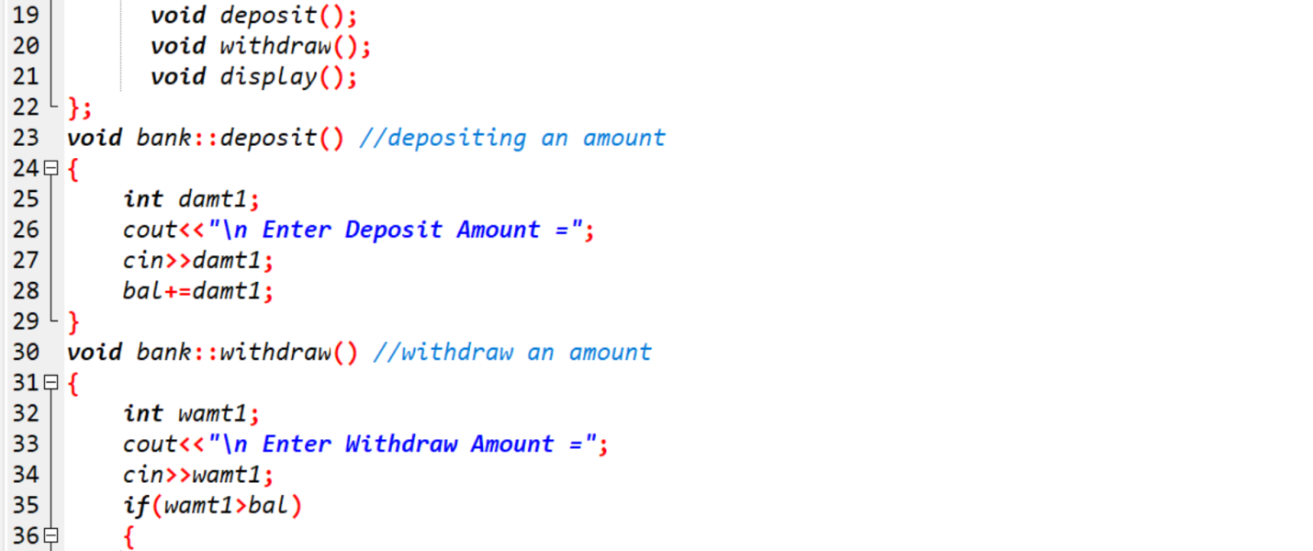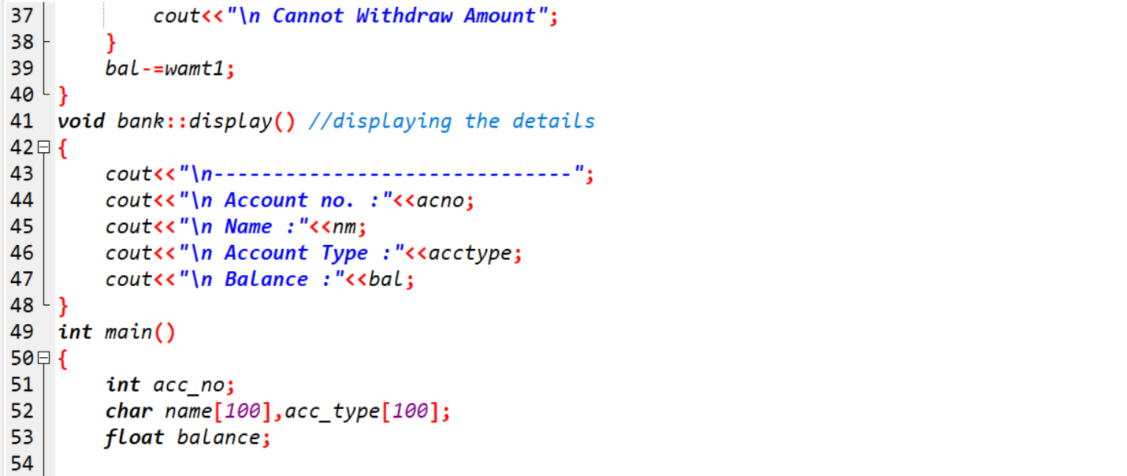

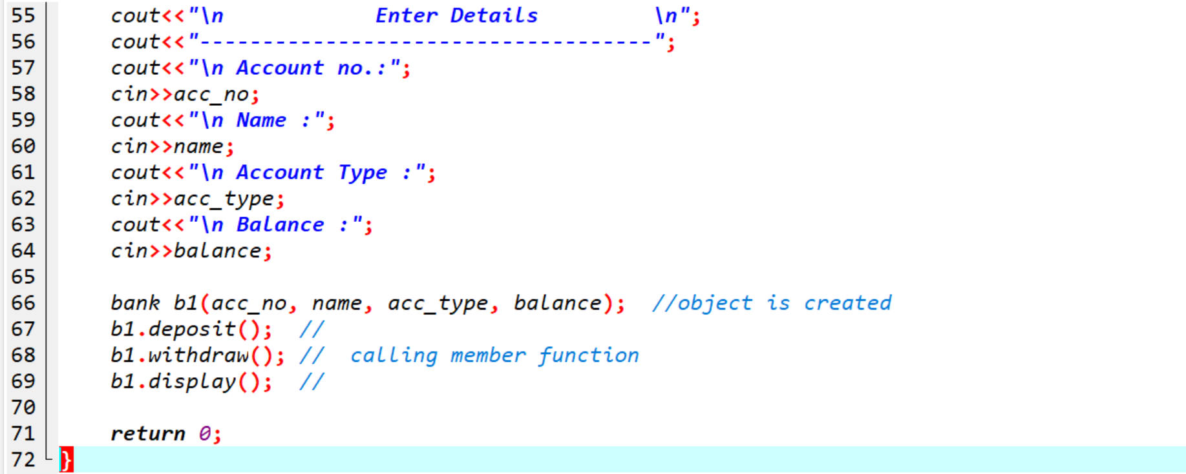

Output:

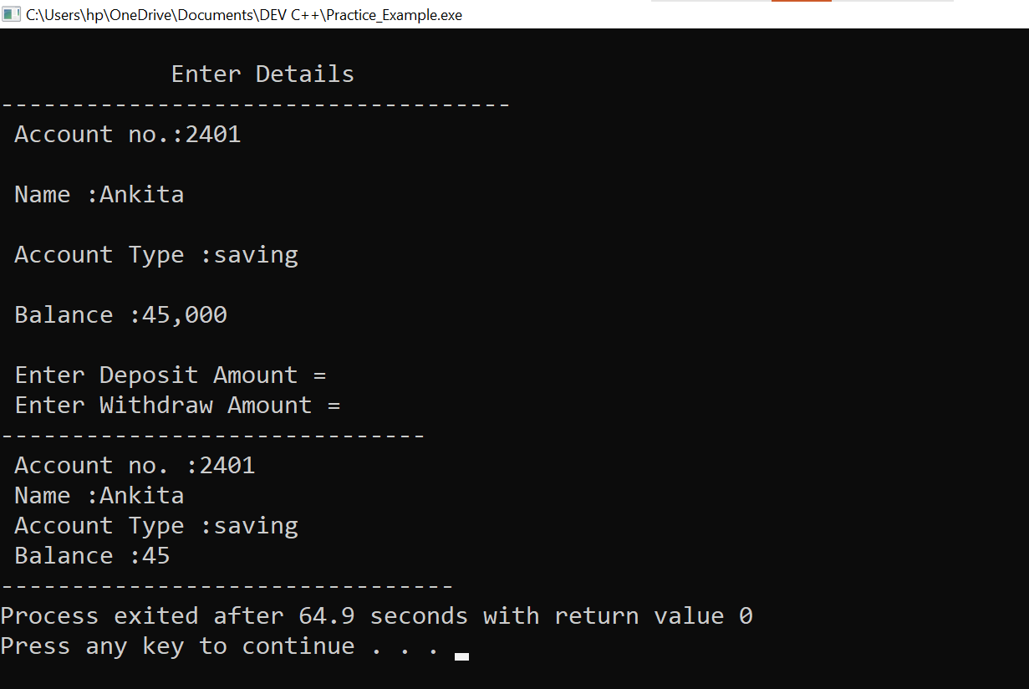

**3.** **Write a program to find the multiplication values and the cubic values using inline function.**

**Ans:-**

Practical:

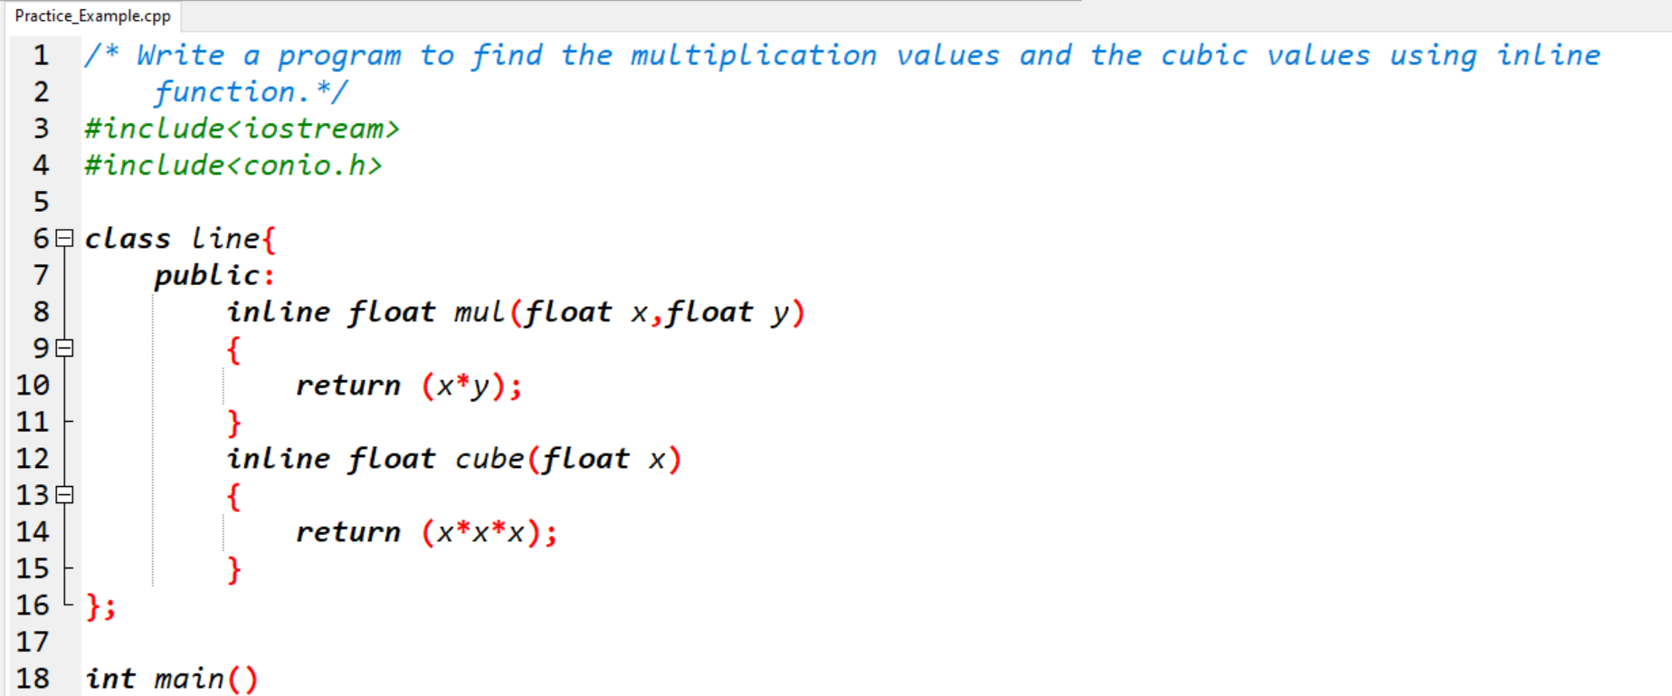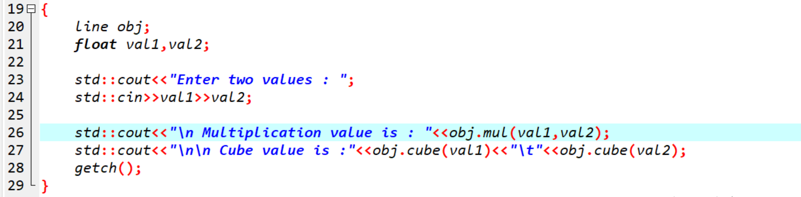

Output:

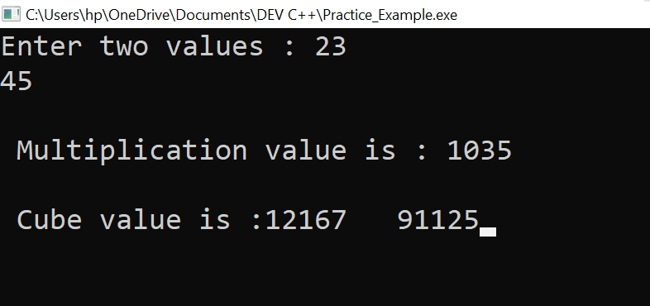

**4.Write a program of Addition, Subtraction, Division, Multiplication using constructor.**

**Ans:-**

Practical:

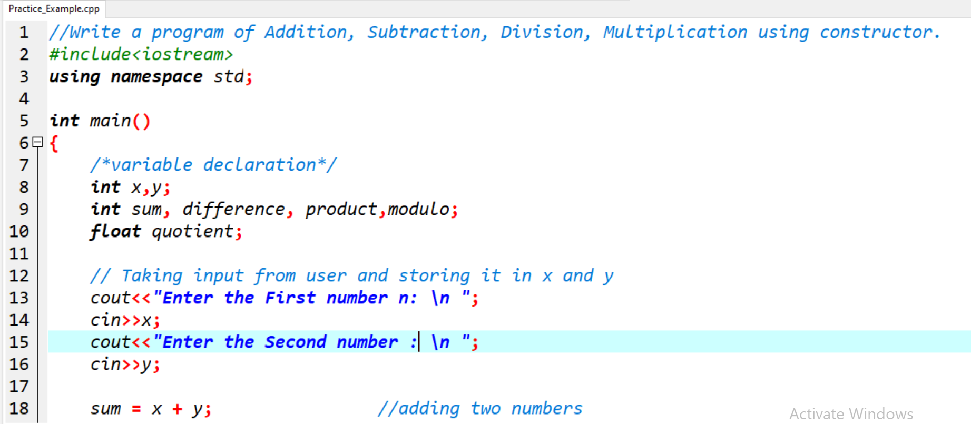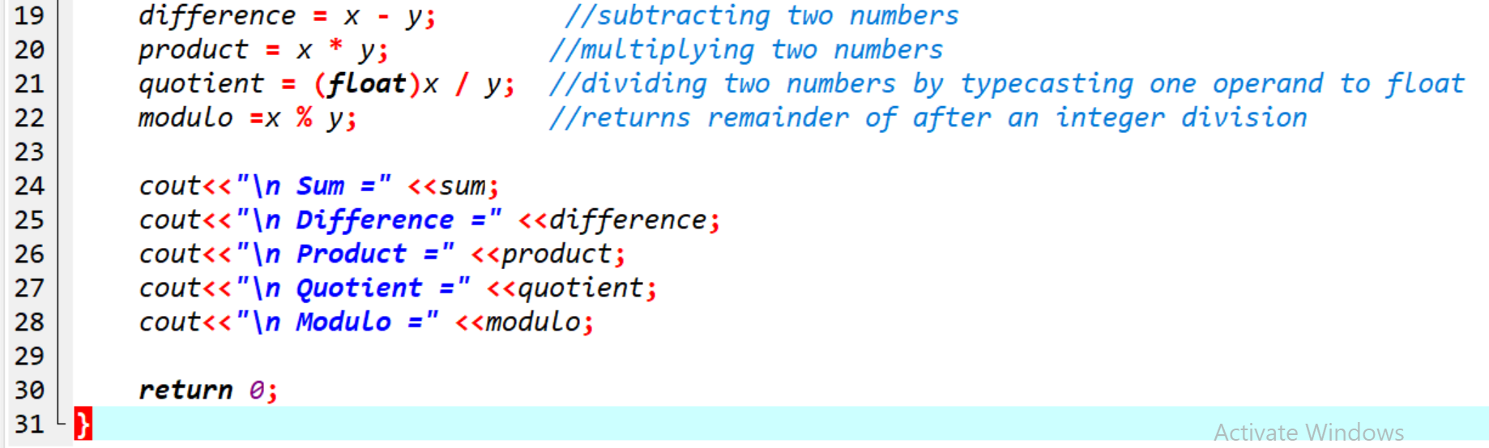

Output:

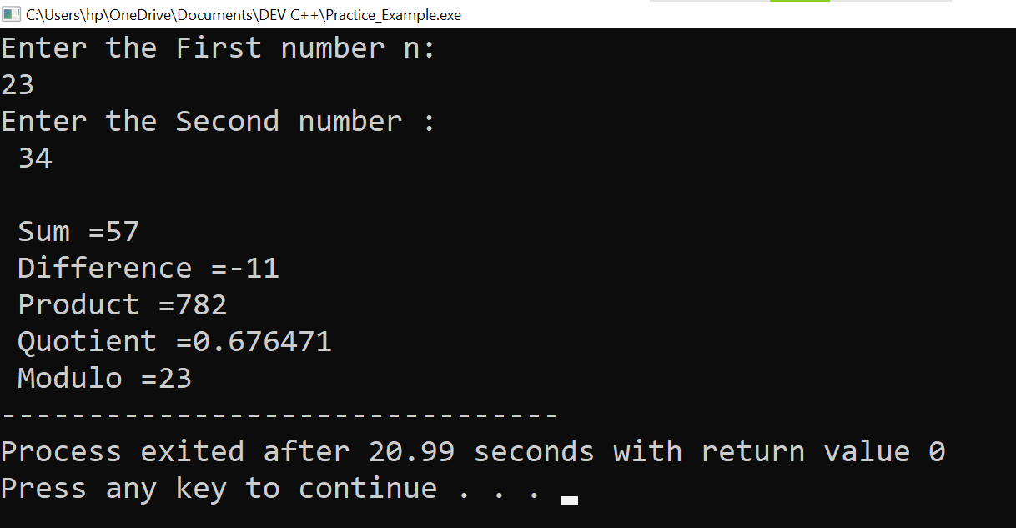

**5.** **Assume a class cricketer is declared. Declare a derived class batsman from cricketer. Data member of batsman. Total runs, Average runs and best performance. Member functions input data, calculate average runs, Display data. (Single Inheritance)**

**Ans:-**

Practical:

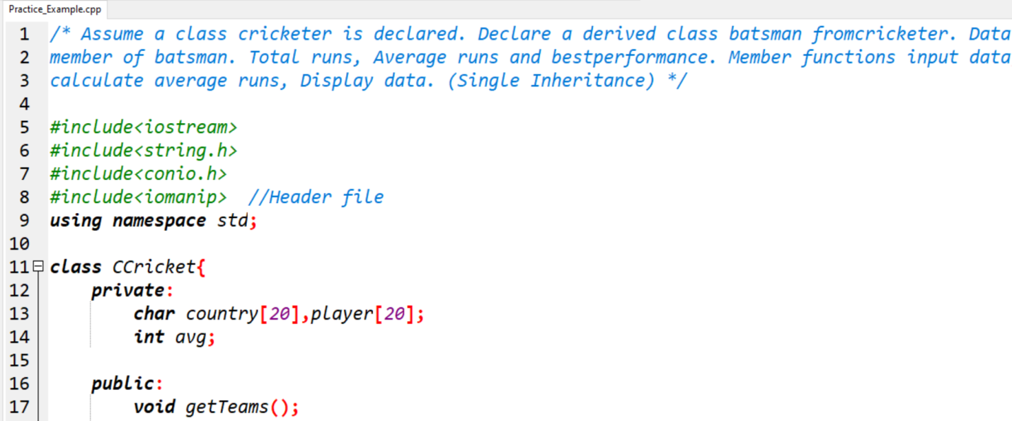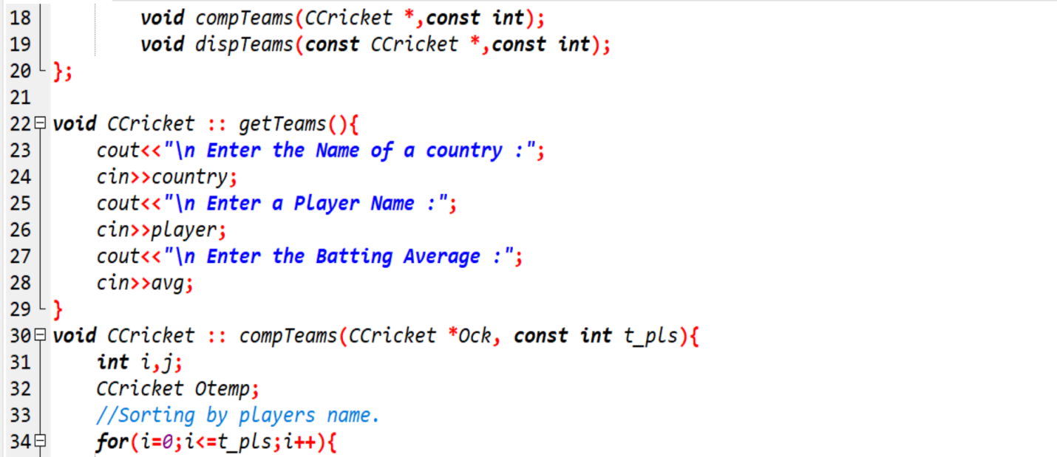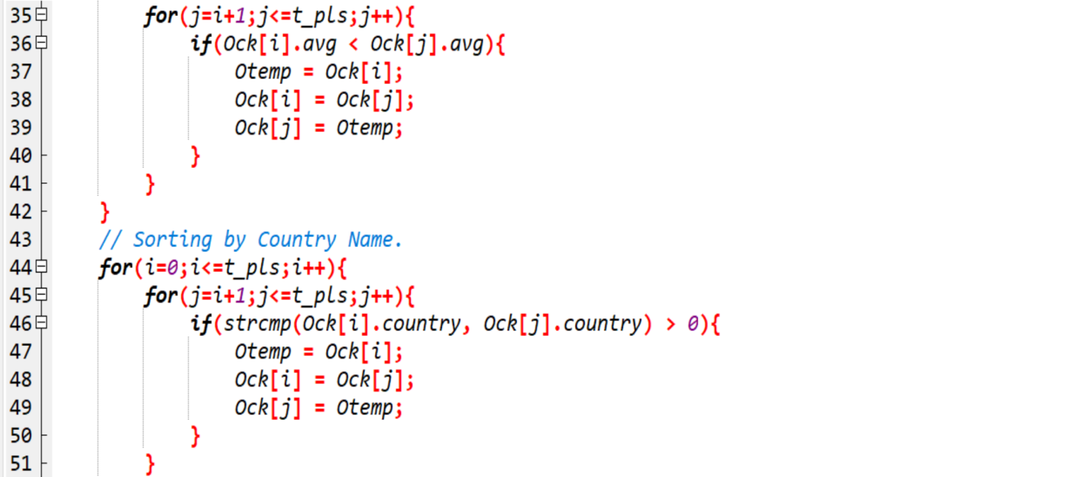

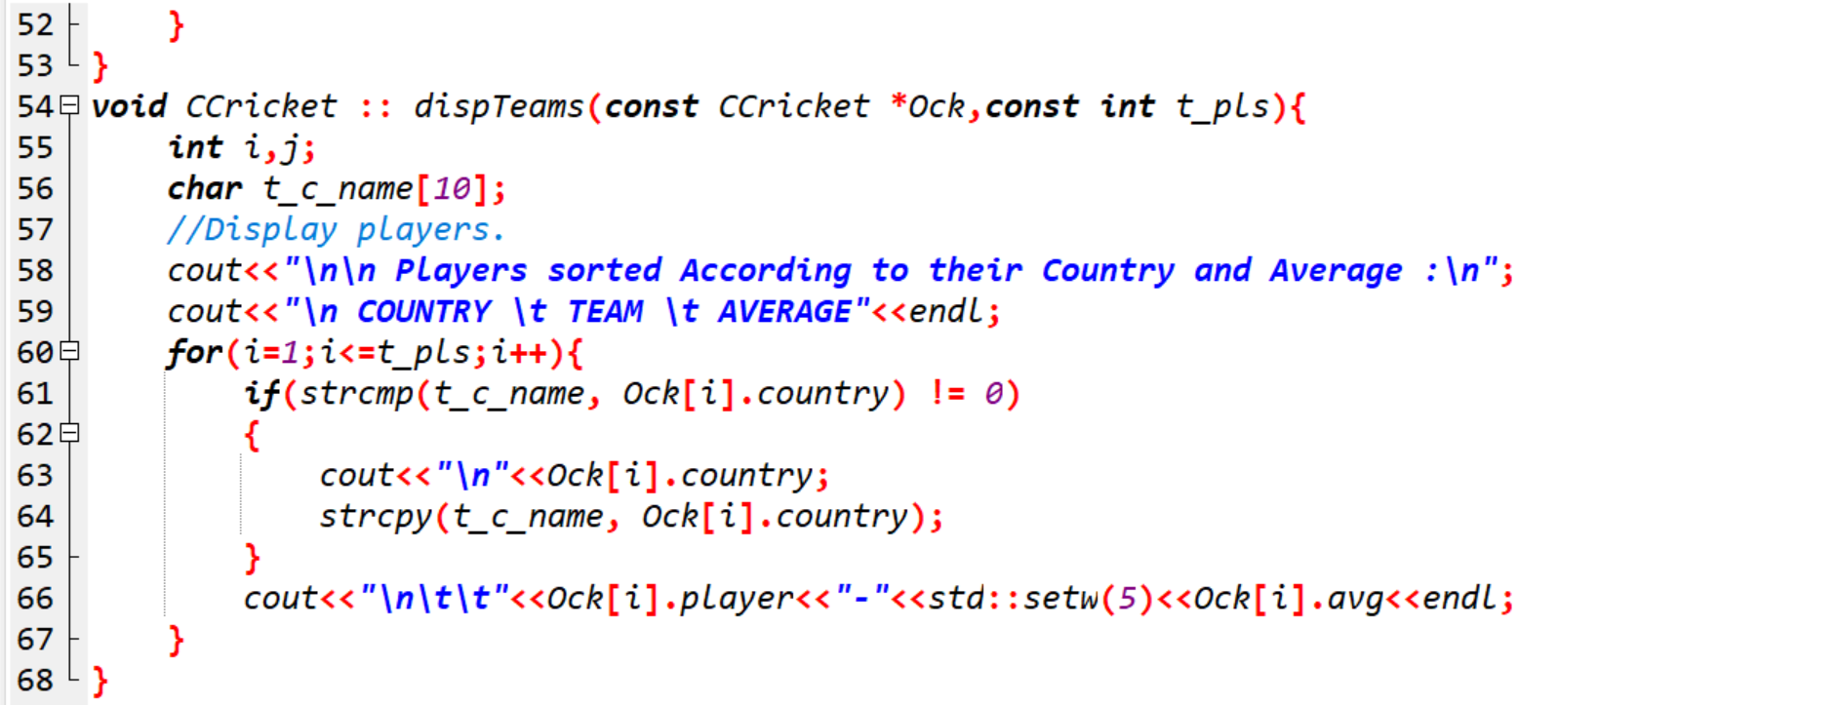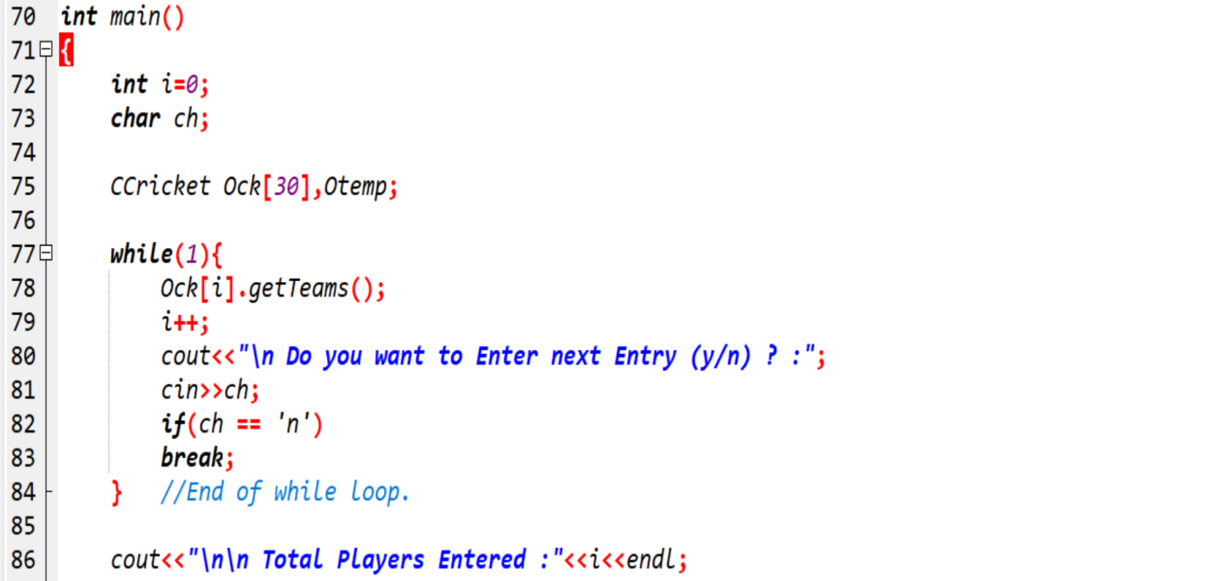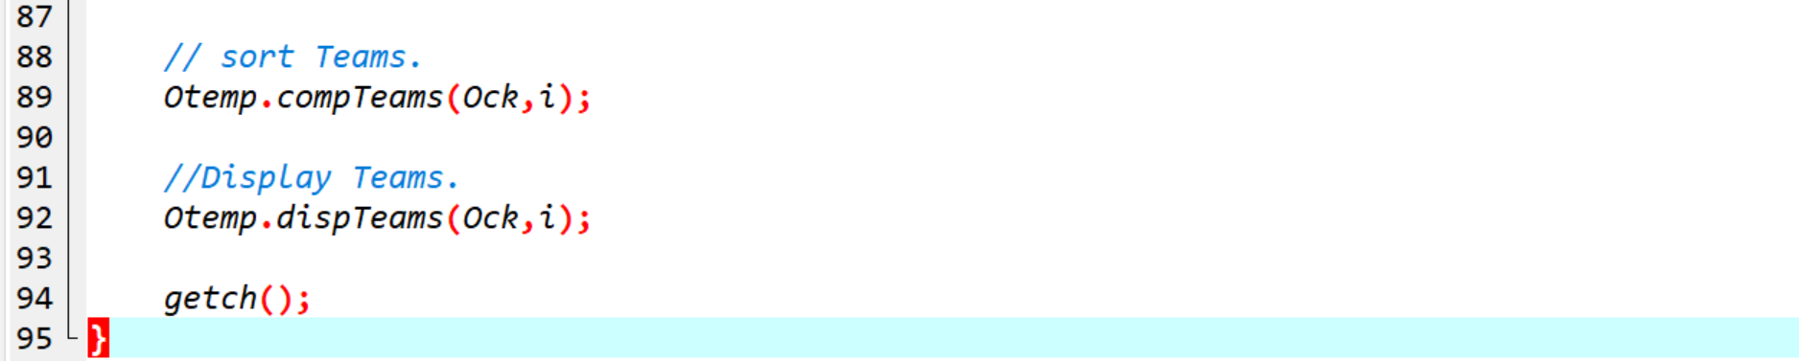

Output:

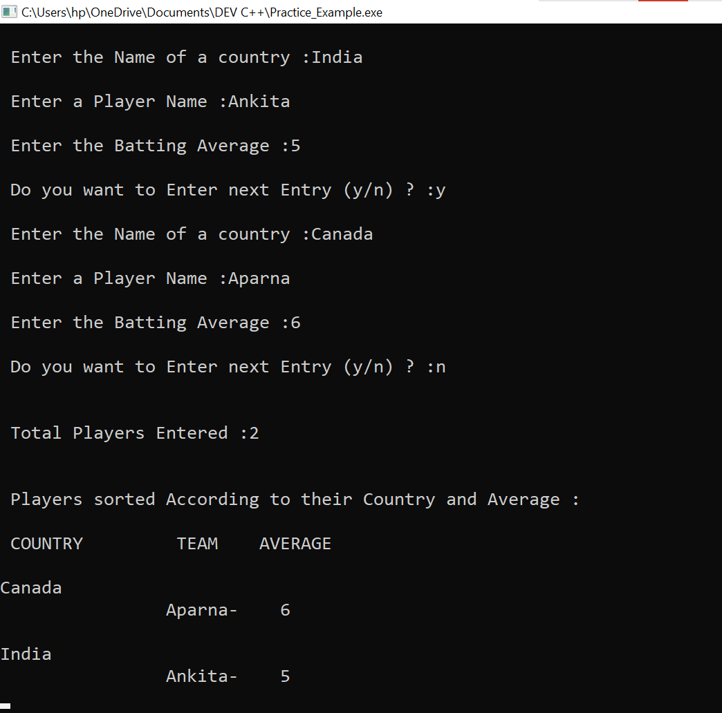

**6.** **Create a class person having members name and age. Derive a class student having member percentage. Derive another class teacher having member salary. Write necessary member function to initialize, read and write data. Write also Main function (Multiple Inheritance)**

**Ans:-**

Practical:

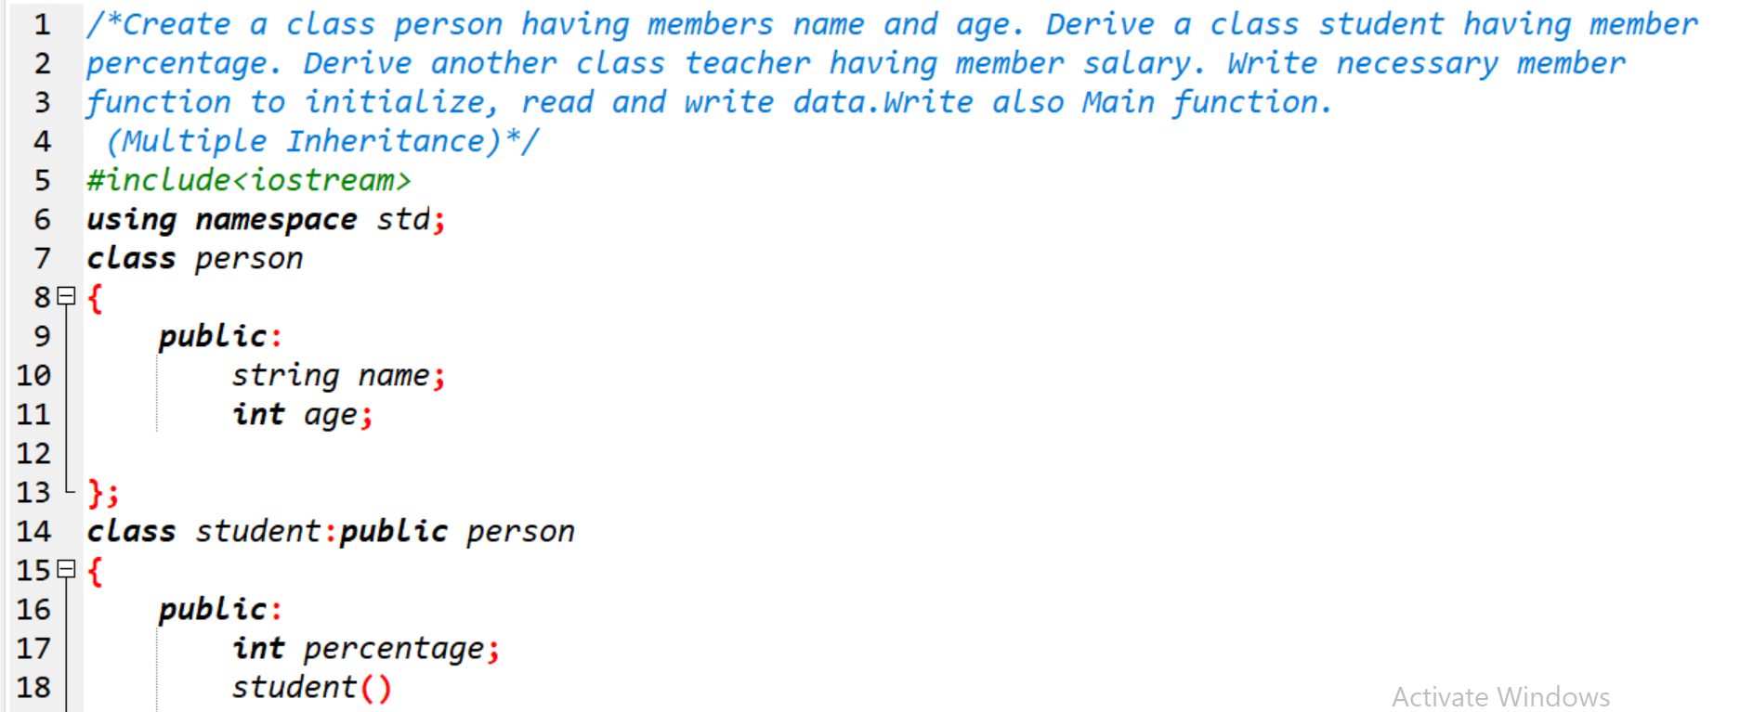

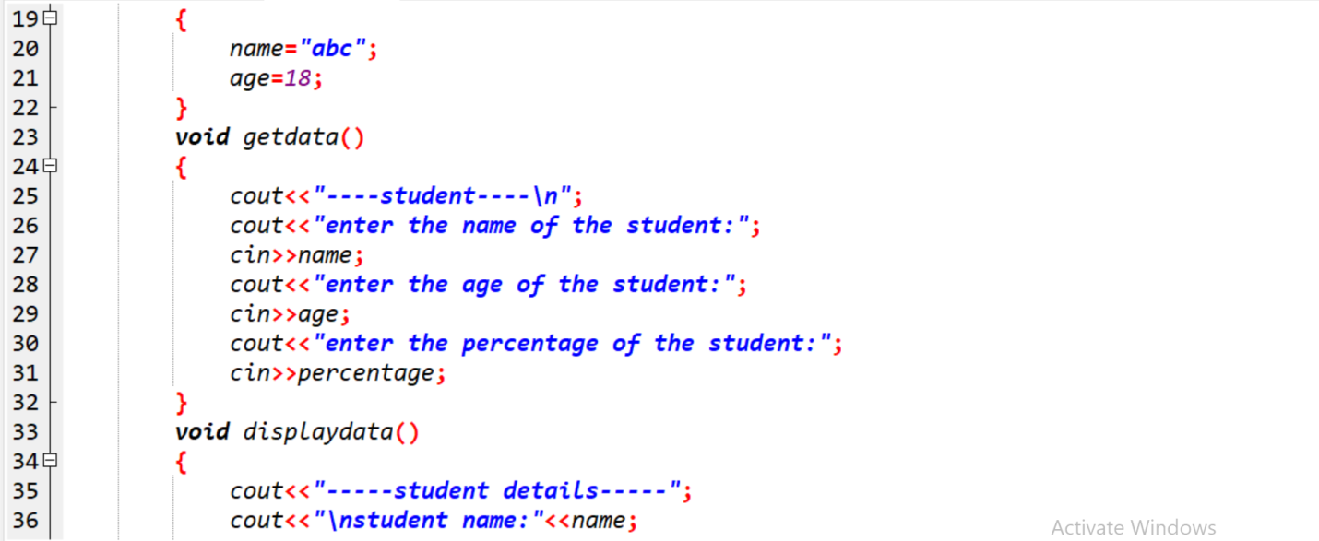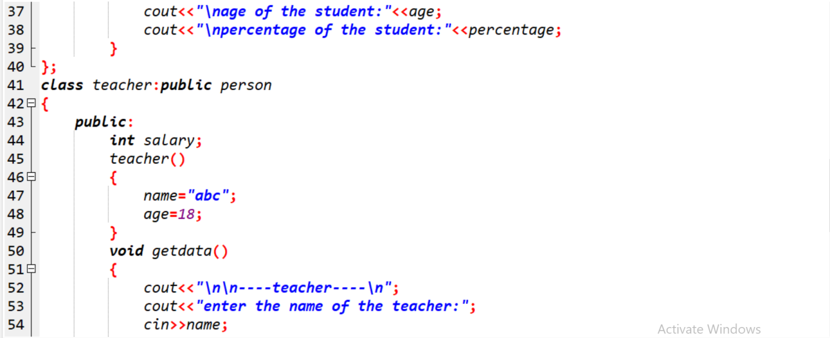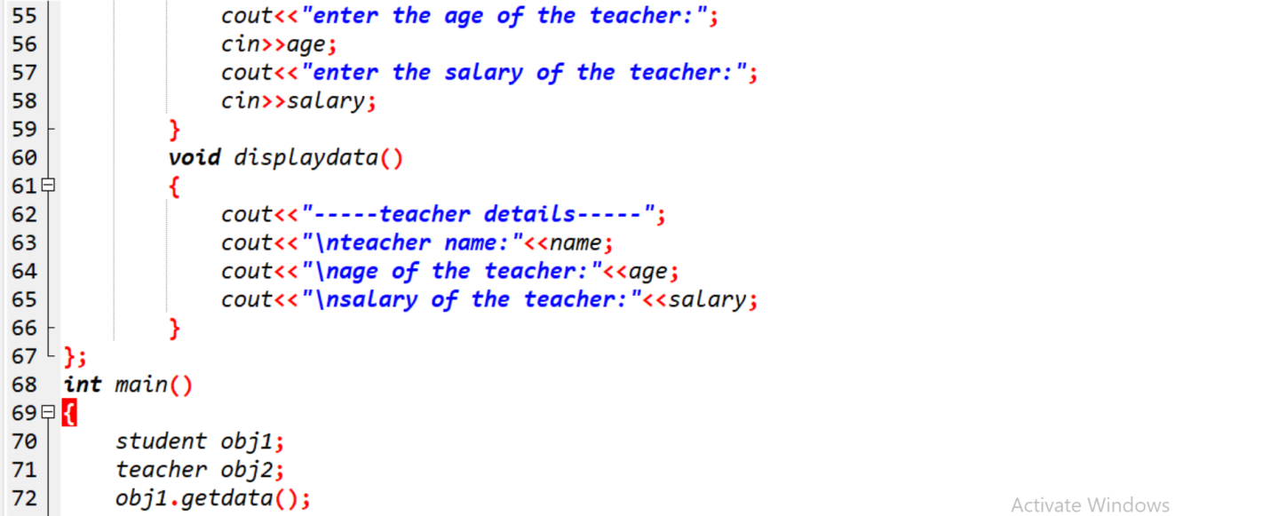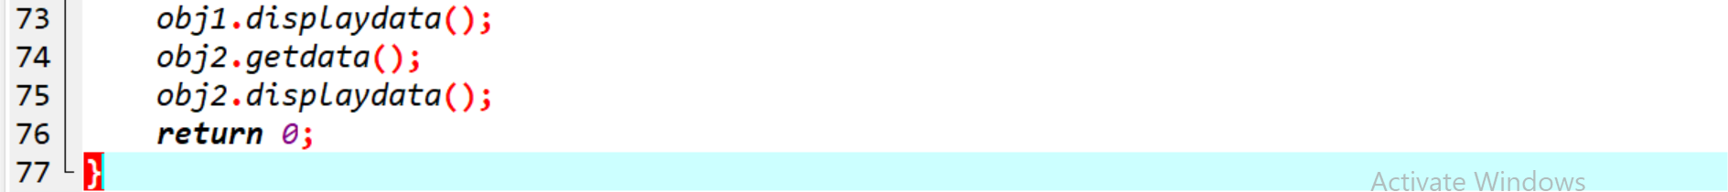

Output:

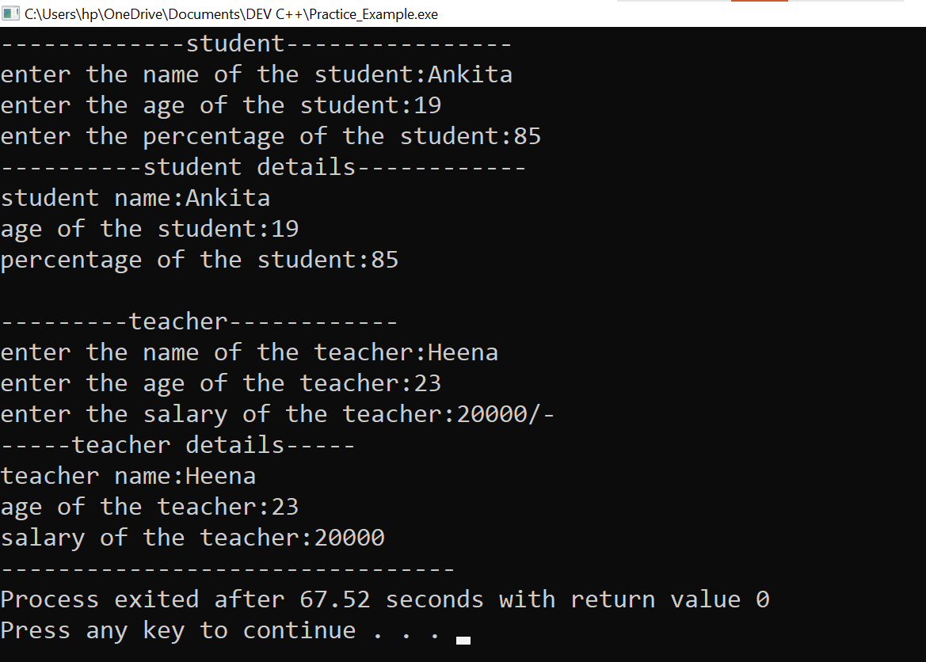

**7.** **Assume that the test results of a batch of students are stored in three different classes. Class Students are storing the roll number. Class Test stores the marks obtained in two subjects and class result contains the total marks obtained in the test. The class result can inherit the details of the marks obtained in the test and roll number of students. (Multilevel Inheritance)**

**Ans:-**

Practical: 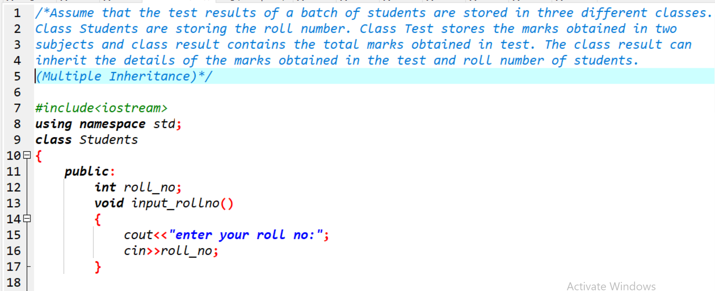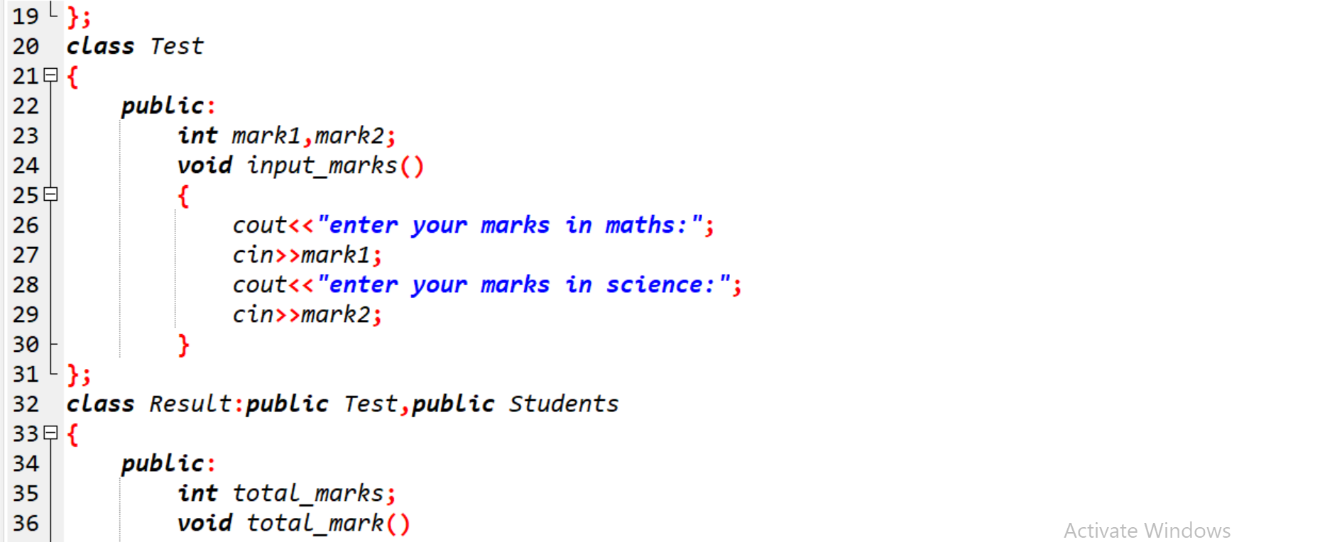 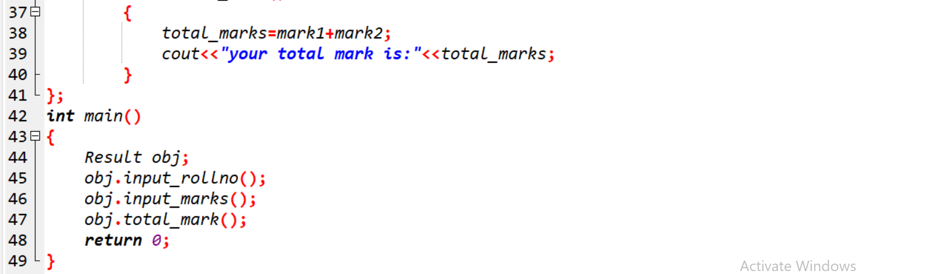

Output:

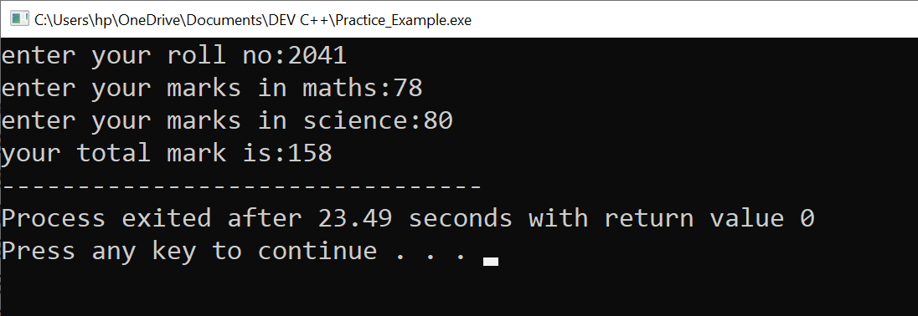

**8.** **Write a program to Mathematic operation like Addition, Subtraction, Multiplication, Division Of two number using different parameters and Function Overloading.**

**Ans:-**

Practical:

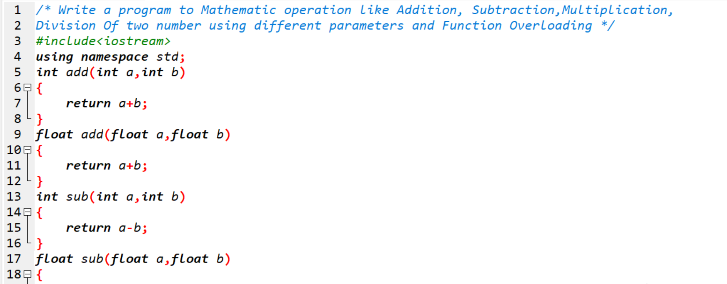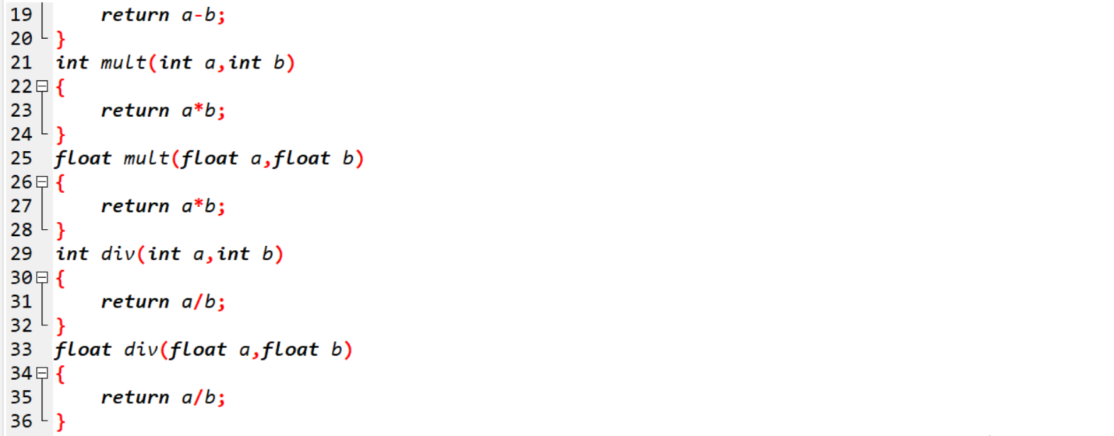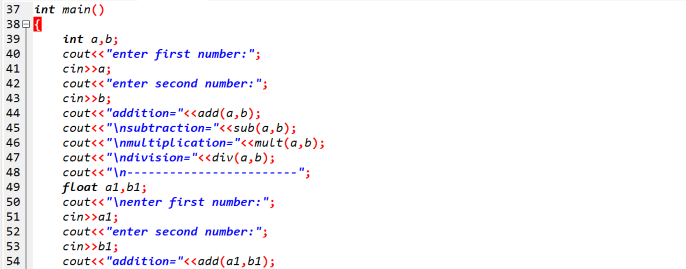

Output:

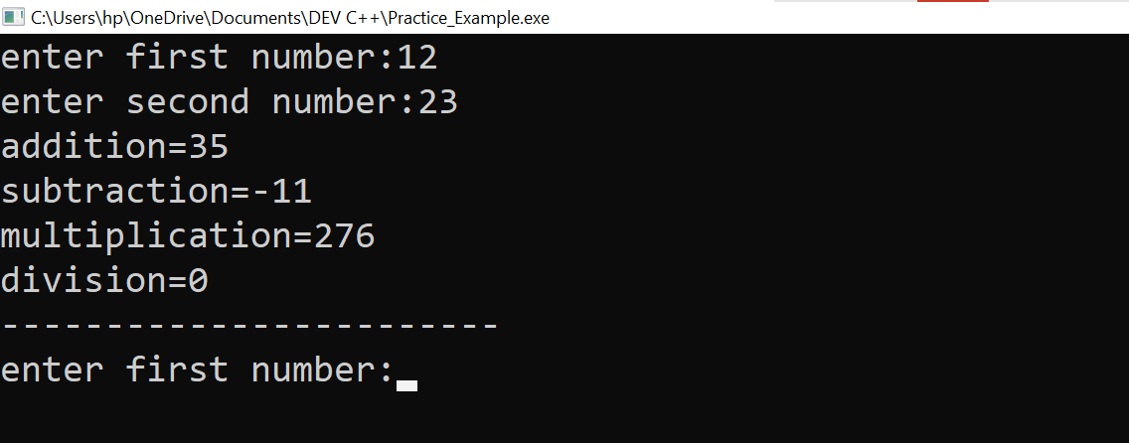

**9. Write a Program of Two 1D Matrix Addition using Operator Overloading.**

**Ans:-**

Practical:

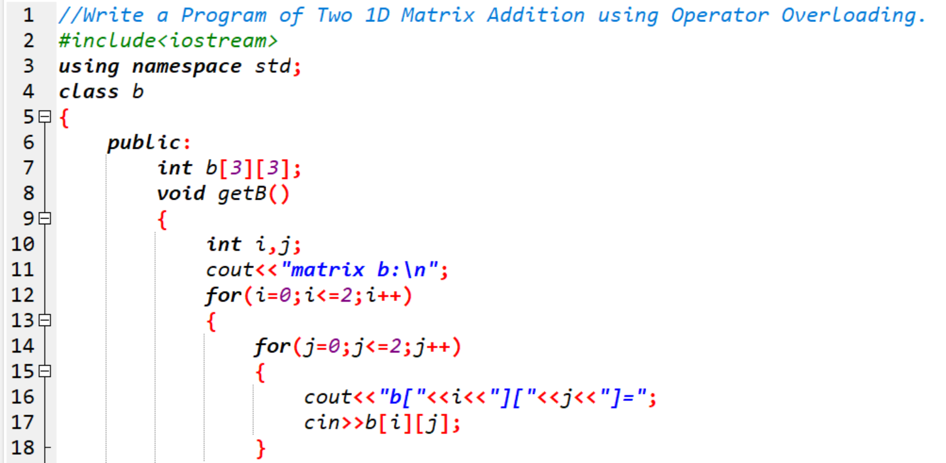

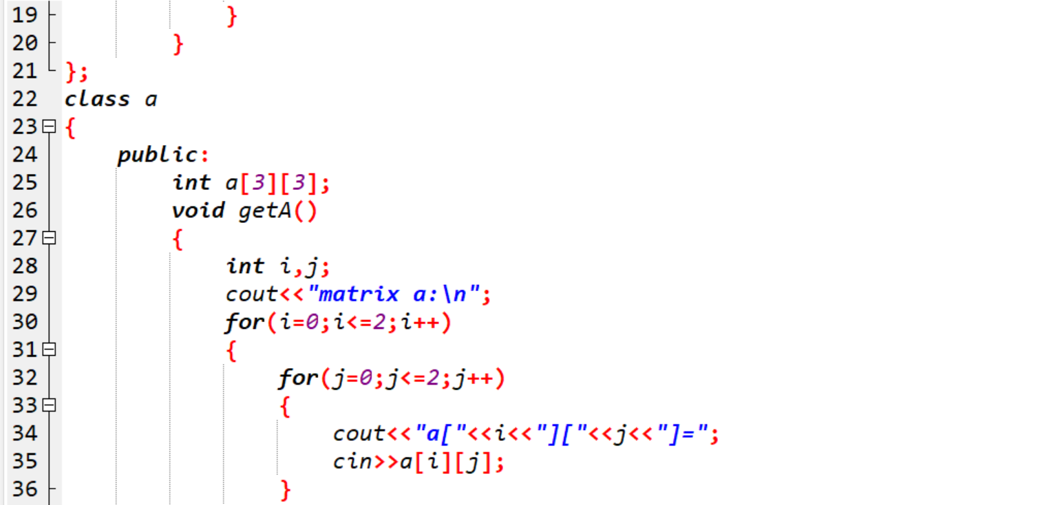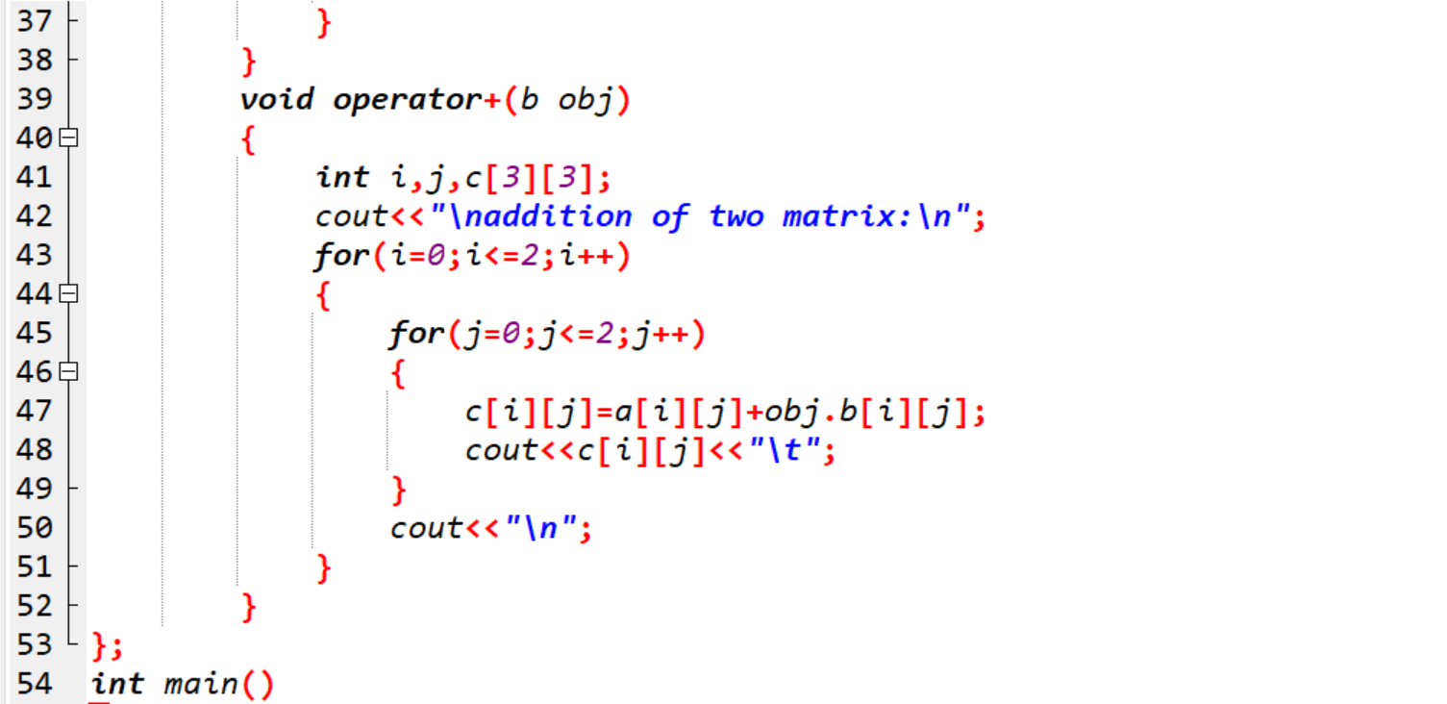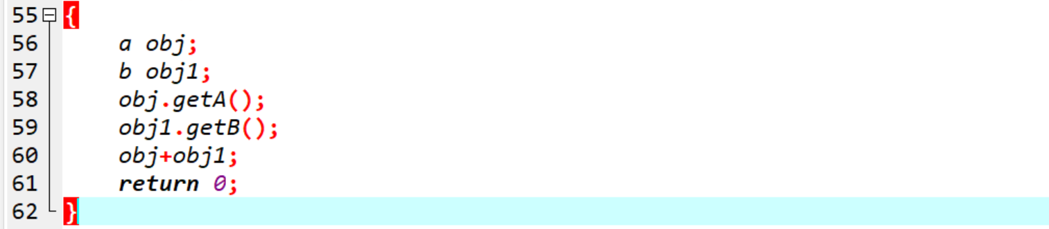

Output:

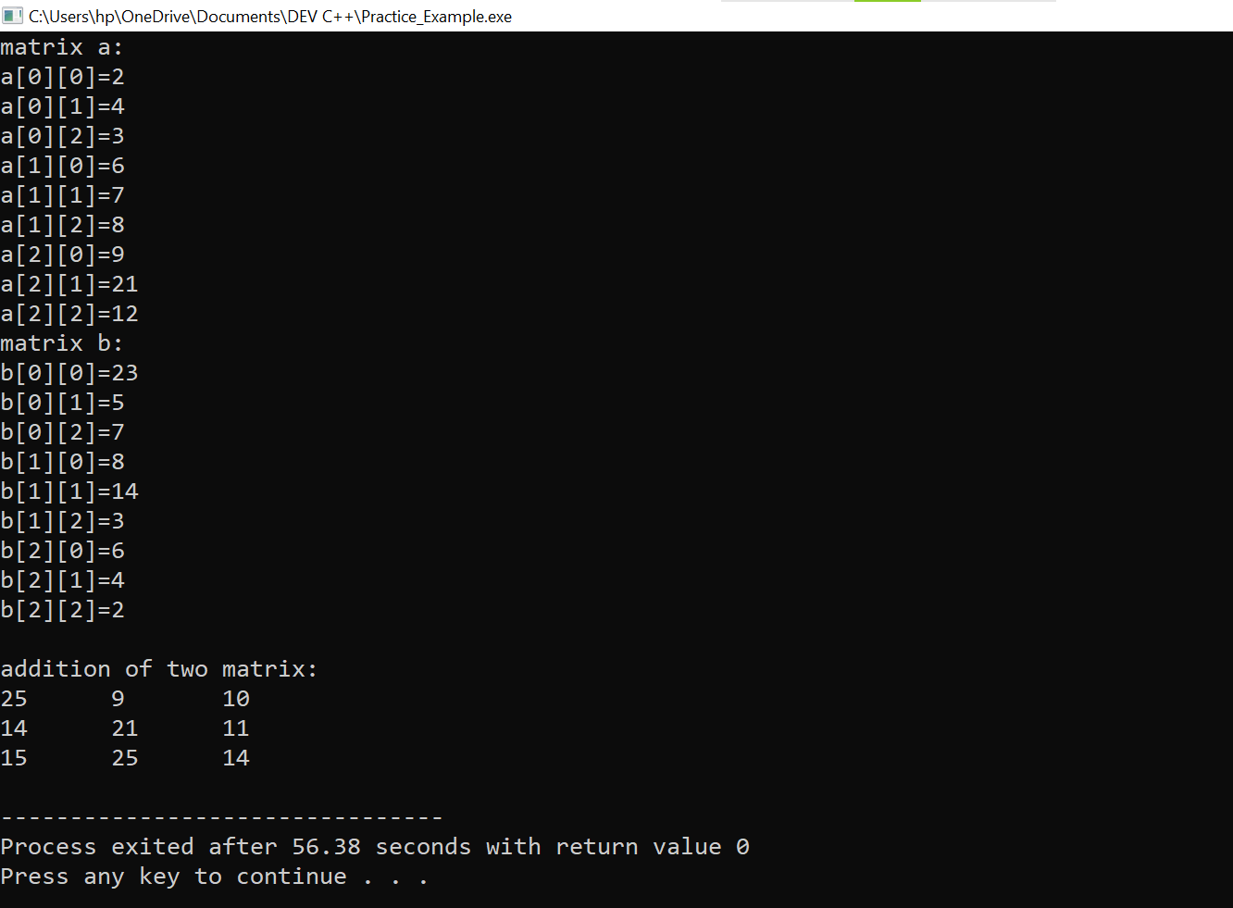

**10. Write a program to concatenate the two strings using Operator Overloading.**

**Ans:-**

Practical:

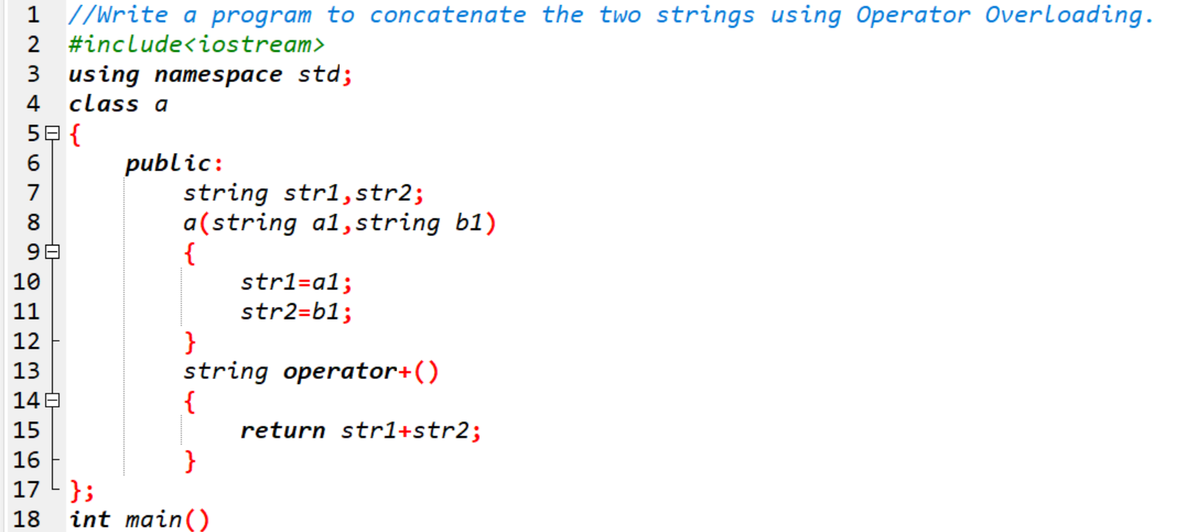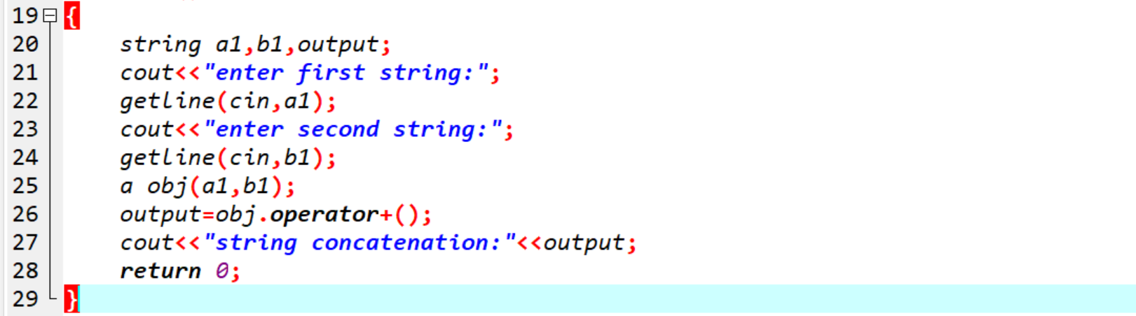

Output:

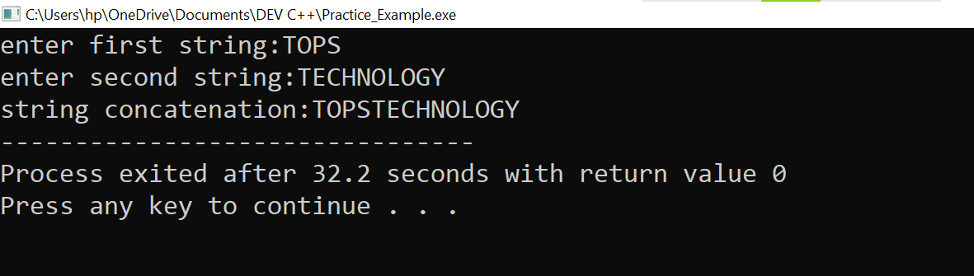

**11. Write a program to calculate the area of circle, rectangle and triangle using Function Overloading .**

* **Rectangle: Area * breadth**
* **Triangle: ½ *Area* breadth**
* **Circle: Pi * Area *Area**

**Ans:-**

Practical:

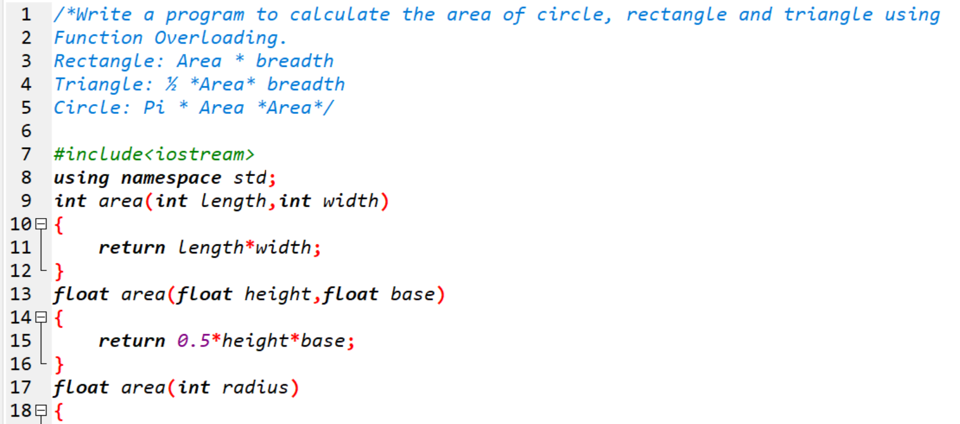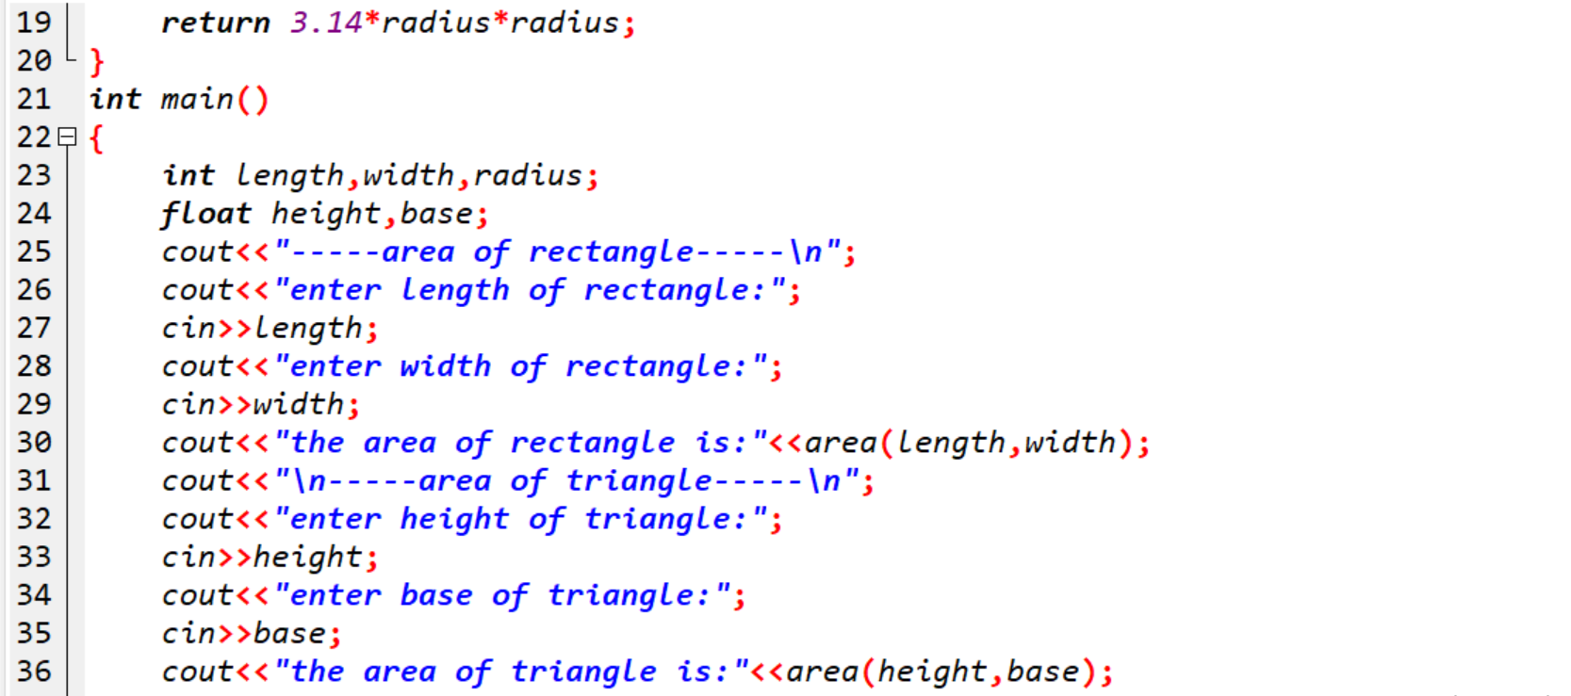

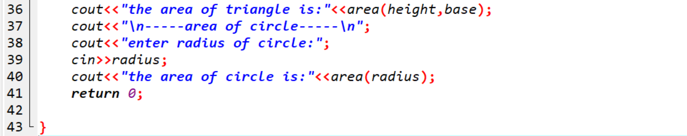

Output:

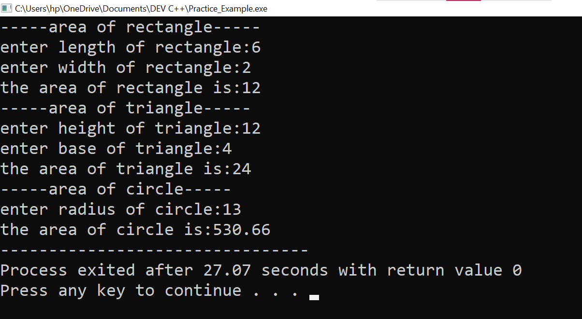

**12. Write a program to swap the two numbers using friend function without using third variable.**

**Ans:-**

Practical:

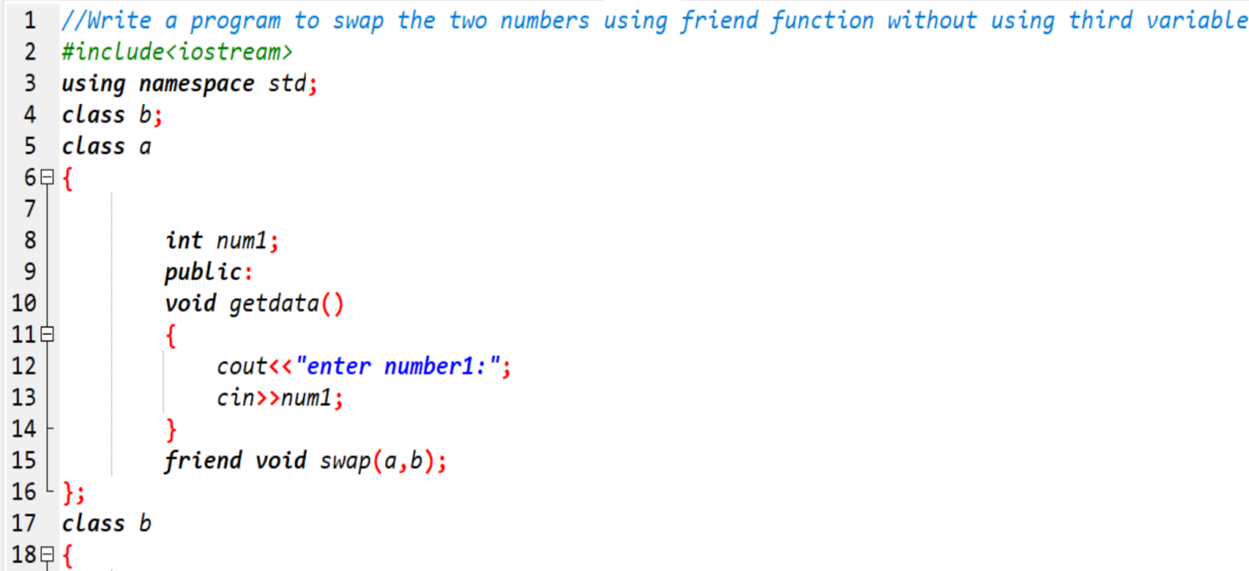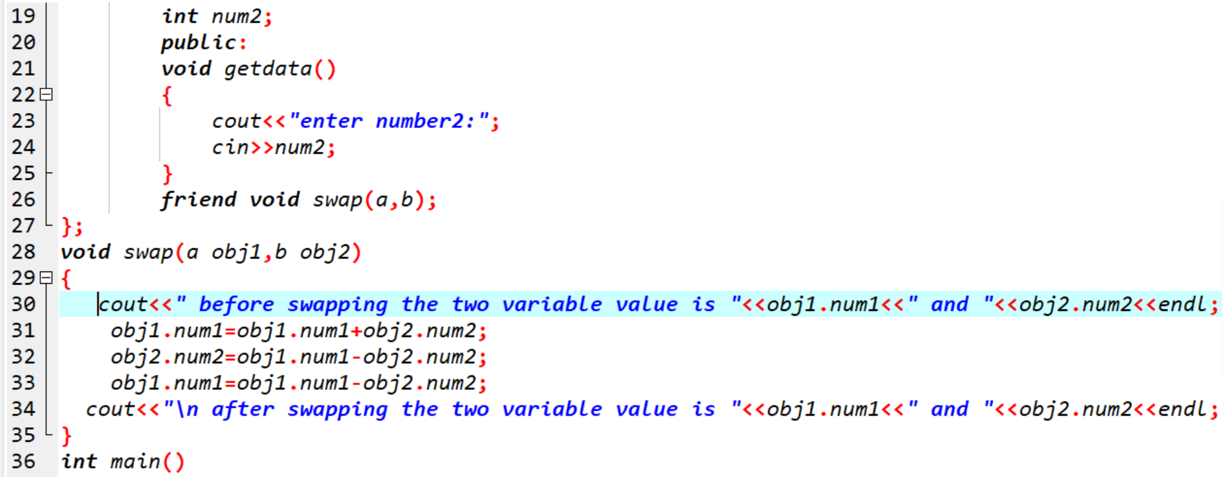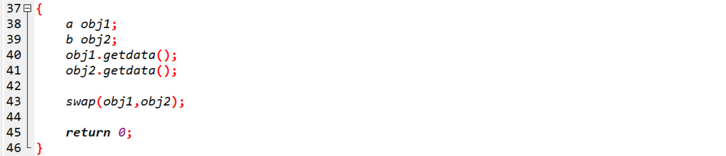

Output:

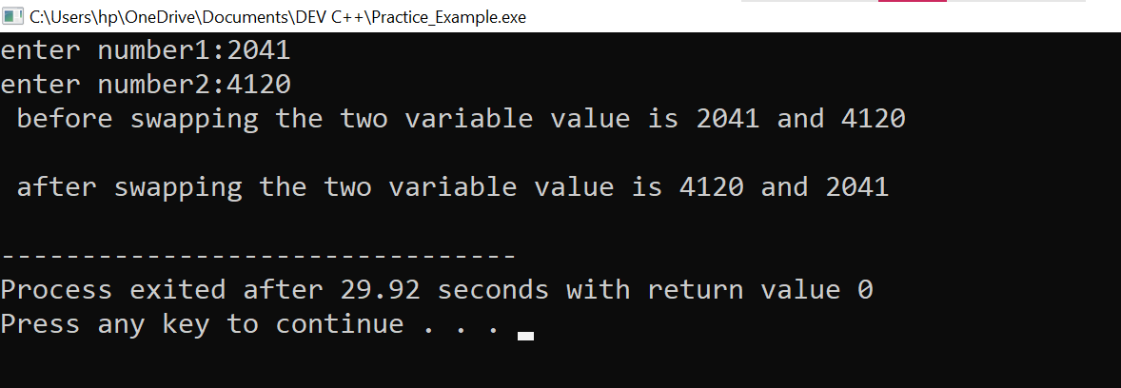

**13. Write a program to find the max number from given two numbers using friend function.**

**Ans:-**

Practical:

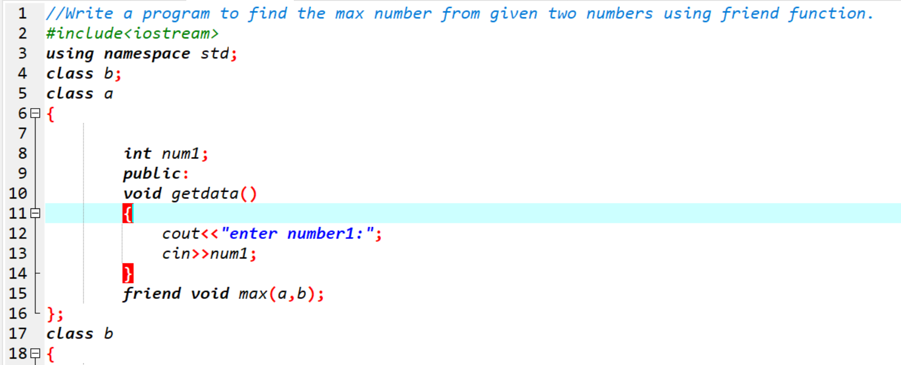

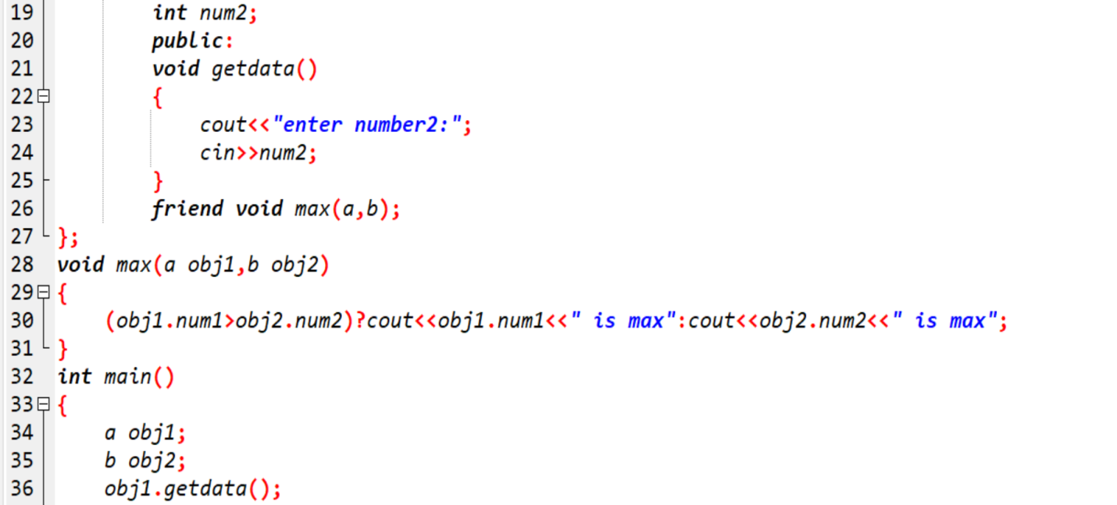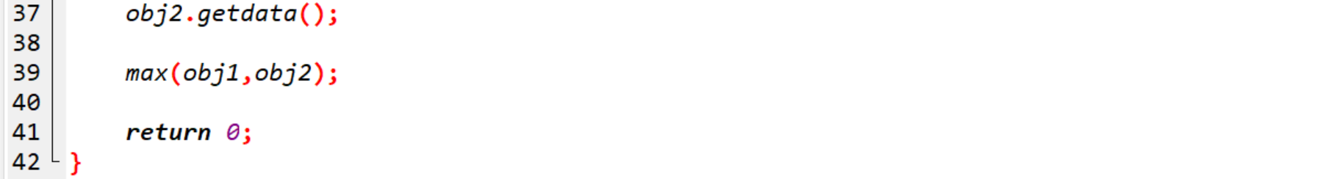

Output:

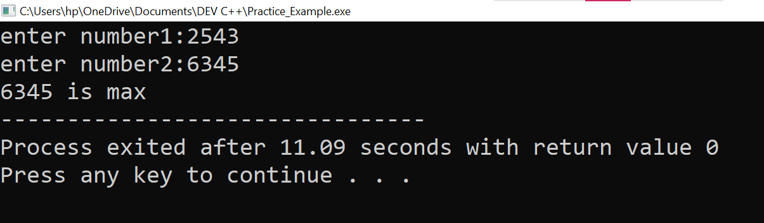

MODULE: 4.2 (C, C++ Templates)

**1. Write a program of to swap the two values using templates.**

**Ans:-**

Practical:

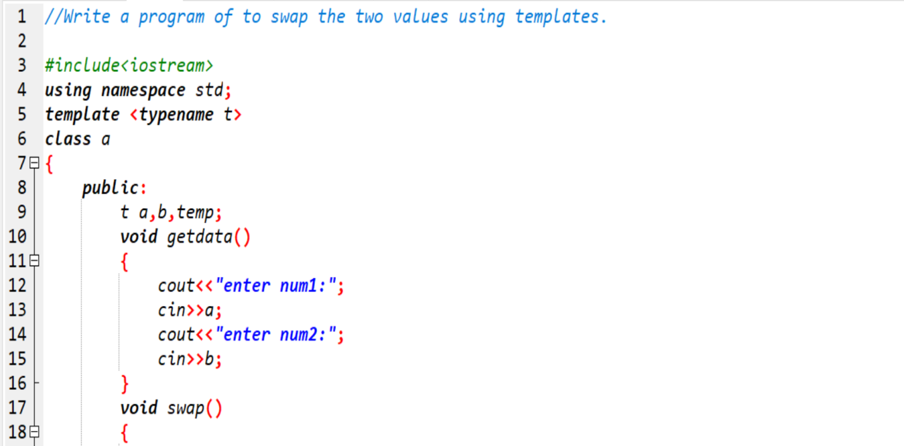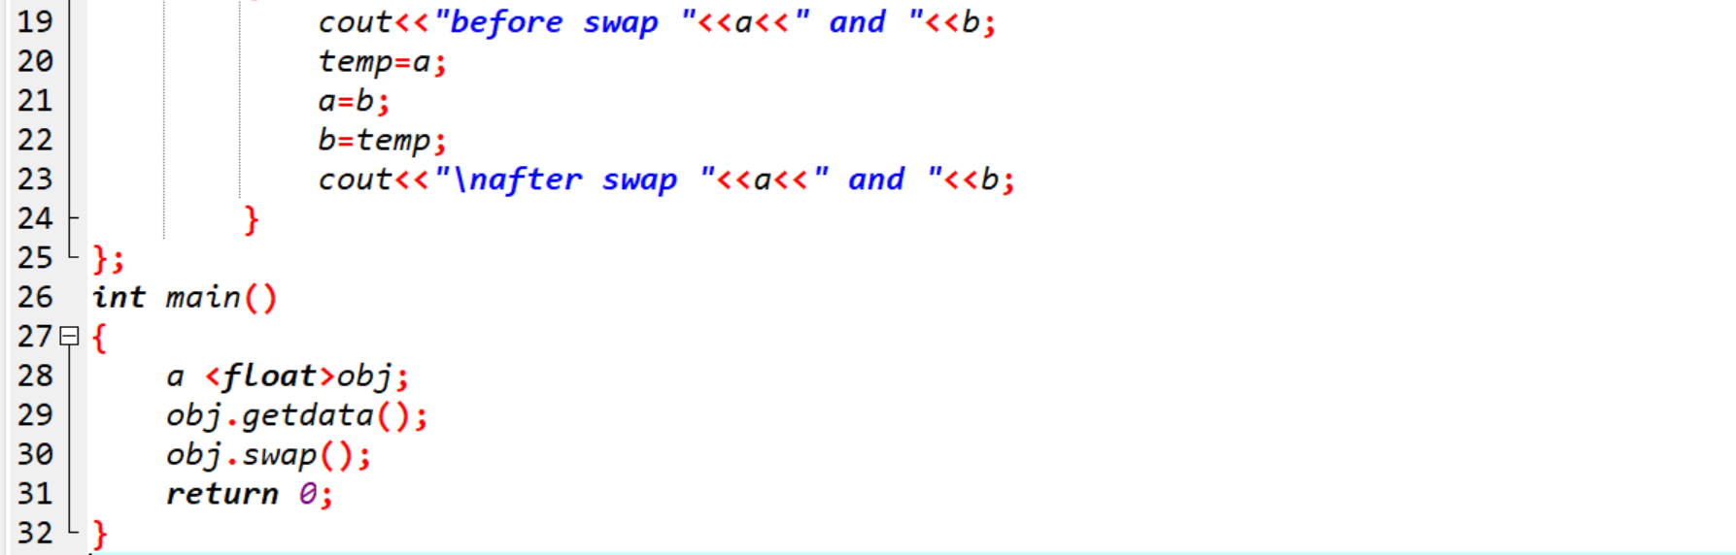

Output:

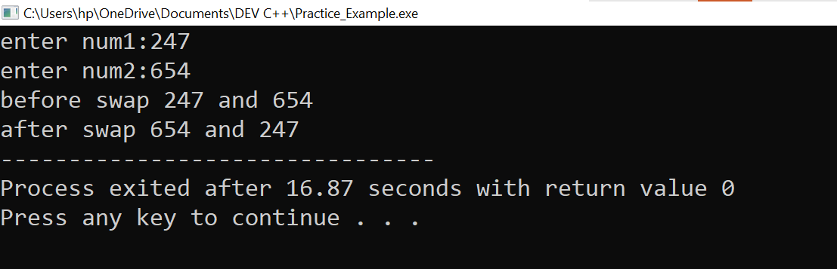

**2. Write a program of to sort the array using templates.**

**Ans:-**

Practical:

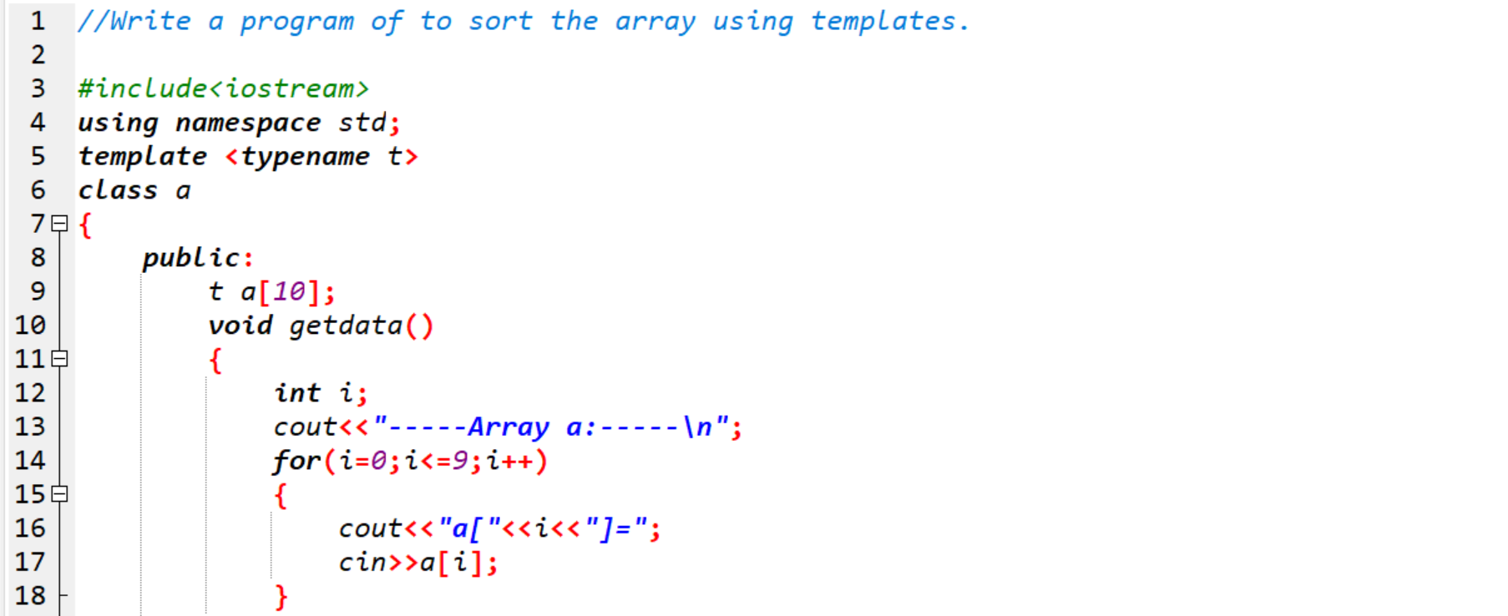

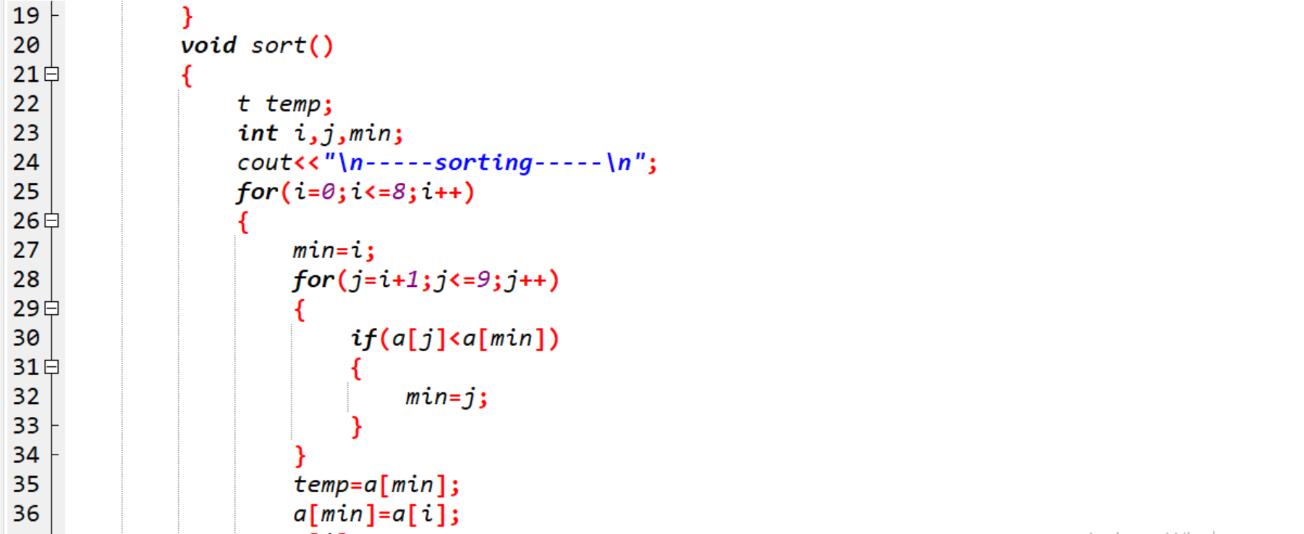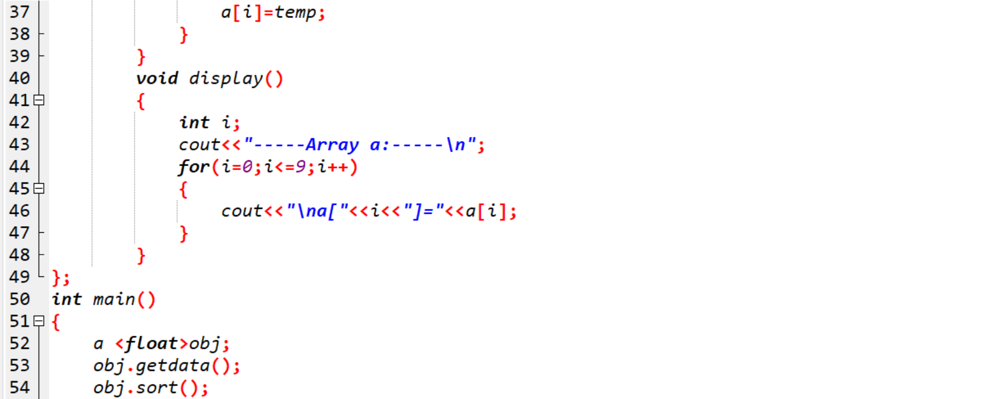

Output:

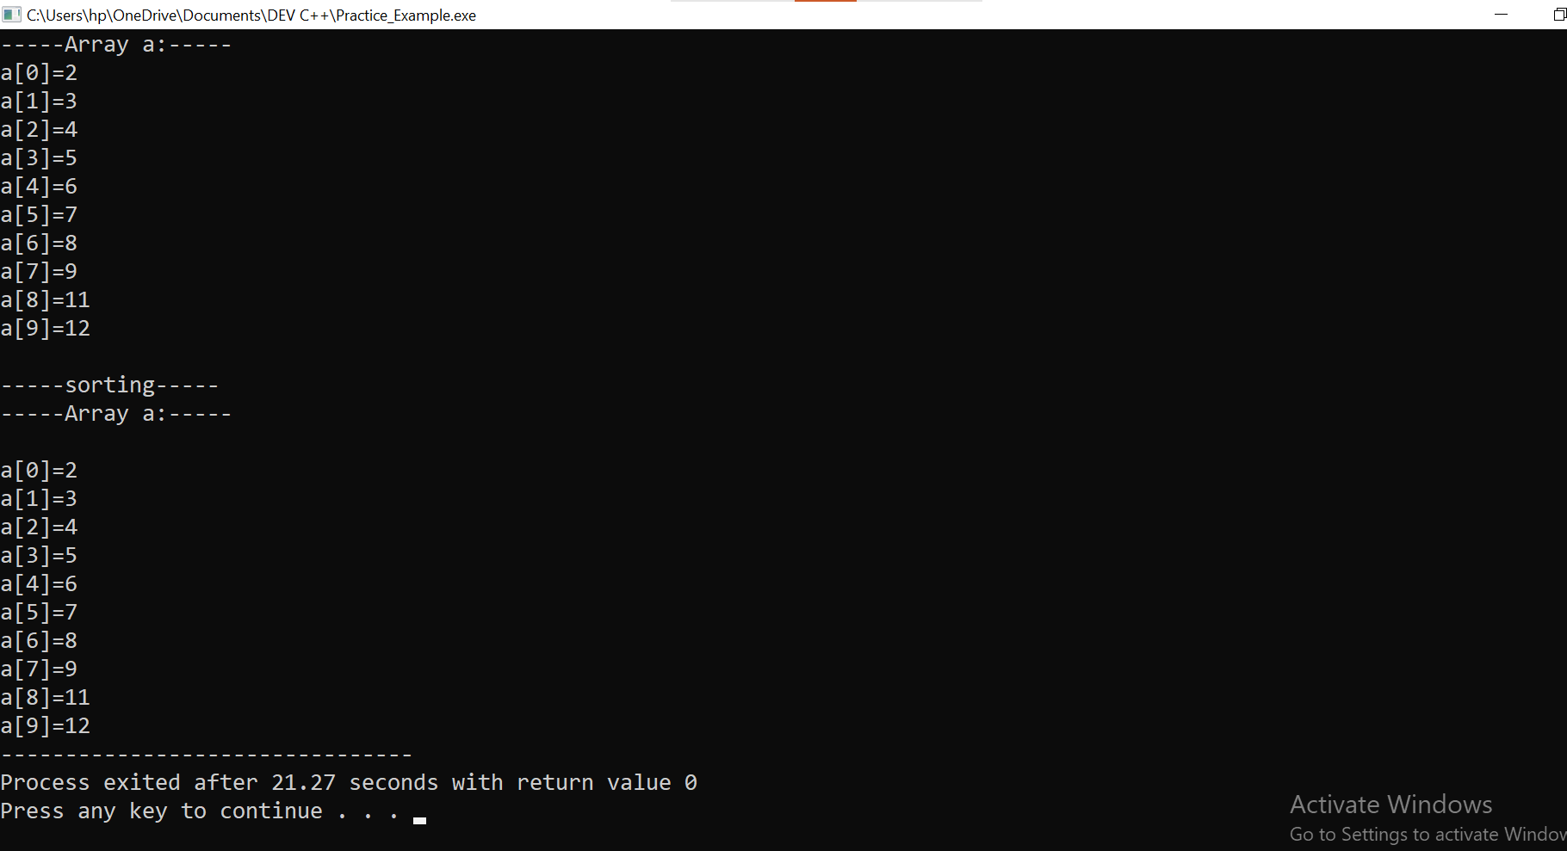

**XOXOXOXOXOXOXO**